08

**Fall**

**FSGIM Implementation Support**

**Contract No. SB1341-14-CQ-0043/ Order No.:16-443**



**Task 6**

**Mapping Document for Decomposition of FSGIM UML Model into**

**XML Resources and Corresponding Schema**

**August 31, 2017**

**Prepared by**

**ESTA International, LLC**

**2214 Rock Hill Road, Suite 180**

**Herndon, Virginia, 20170-4234, USA**



[www.ESTAInternational.com](http://www.ESTAInternational.com)

ESTA International, LLC has prepared this document under contract to NIST under contract number SB1341-14-CQ-0043/ order no.:16-443. Unless otherwise noted all information in this document is confidential and proprietary.

This work was completed through close cooperation between

NIST and ESTA International Project Team members.

NIST Project Team Members includes:

Dr. Martin J. Burns Project Technical Lead

Mr. Paul Boynton Project Manager

ESTA team members for this project include:

Mr. Nader Farah Project Manager

Mr. Allen J. Jones FSGIM Model Subject Matter Expert

Mr. Donald F. Coffin OpenESPI/ Green Button Subject Matter Expert

Mr. Joseph Moran Technical Expert

Please address all inquiries to:

Mr. Nader Farah

ESTA International, LLC

[nader.farah@ESTAinternational.com](mailto:nader.farah@ESTAinternational.com)

Table of Contents

1 Overview 1

2 Creating the Schema from the FSGIM Model 2

2.1 Annotation Errors 2

2.2 Remapping of Primitive Types to XSD Schema Types 4

2.3 Revised Treatment of Enumerations 7

2.4 Revised Treatment of Redefines 7

2.5 OASIS Schema Modifications 14

2.6 Other Changes Related to Issues with the Original FSGIM Model 17

2.7 Enhancements to the Schema 17

2.8 Conversion to Atom Resources 19

2.9 Profiling of the Model 23

2.10 Manual Schema Editing 30

Appendix A. Supplemental Information 31

A.1 Second Round of Schema Generation Errors 31

A.2 Elimination of <<CodeList>> Stereotype 31

A.3 Task 2 Representation of Real Power 32

A.4 Task 6 Representation of Real Power 33

A.5 Task 2 Representation of DemandAggregation 34

A.6 Task 6 Representation of DemandAggregation 36

A.7 Issues with the Original FSGIM Model 38

A.7.1 PowerThermalQuantityRuleset is Missing Initializers (Ticket 679) 38

A.7.2 Need to change defined value for watts per square meter (Ticket 680) 38

A.7.3 AbstractObject Class should be abstract (Ticket 681) 38

A.7.4 The centre attribute of TropicalCyclone duplicates the centre association (Ticket 682) 38

A.7.5 Some Elements in the Weather Model are Never Referenced (Ticket 683) 38

A.7.6 IEC 61850 SequenceDirectionENS Schema Error 39

A.7.7 Modification of Customer, CustomerAuthorisation, and MeterReading 39

A.7.8 The attributes of DQ_Element have the multiplicities included as part of the attribute name 39

A.7.9 Some Information that is required by the FSGIM Weather model is not readily available 39

A.8 Creating an <<XSDUnion>> in Enterprise Architect 40

A.9 Modifying GluonType to Allow for Schema Validation 46

A.10 Applying Pattern Restrictions 47

A.11 Applying Fixed Restrictions 47

A.12 Newly Added Atom Resources 49

A.13 Merged Classes 50

A.13.1 Precipitation 50

A.13.1.1 Atom links and hrefs before 50

A.13.1.2 Atom links and hrefs after 50

A.13.2 AbstractReport 51

A.13.2.1 Atom links and hrefs before 51

A.13.2.2 Atom links and hrefs after 51

A.13.3 AbstractObject and AbstractGML 52

A.13.3.1 Atom links and hrefs before 52

A.13.3.2 Atom links and hrefs after 52

A.13.4 AviationWx 53

A.13.4.1 Atom links and hrefs before 53

A.13.4.2 Atom links and hrefs after 53

A.13.5 TREND 54

A.13.5.1 Atom links and hrefs before 54

A.13.5.2 Atom links and hrefs after 54

A.13.6 Aerodrome 55

A.13.6.1 Atom links and hrefs before 55

A.13.6.2 Atom links and hrefs after 55

A.13.7 WX_Observation::Observation 56

A.13.7.1 Atom links and hrefs before 56

A.13.7.2 Atom links and hrefs after 56

A.13.8 Forecast 57

A.13.8.1 Atom links and hrefs before 57

A.13.8.2 Atom links and hrefs after 58

A.13.9 BaseWarrantType and QualityWarrantType 60

A.13.9.1 Atom links and hrefs before 60

A.13.9.2 Atom links and hrefs after 60

A.13.10 IntervalDataContainerRestrictions 61

A.13.11 Sequence 61

A.13.12 Circuit 62

A.13.13 ProductDescriptionType 62

A.13.13.1 Atom links and hrefs before 62

A.13.13.2 Atom links and hrefs after 63

A.13.14 ResourceDescriptionType 63

A.13.14.1 Atom links and hrefs before 64

A.13.14.2 Atom links and hrefs after 64

A.13.15 GenerationType 65

A.14 Manual Schema Edits for Ordering of Elements 65

A.14.1 emissions_meas.xsd 65

A.14.2 energy_meas.xsd 66

A.14.3 fsgimweather.xsd 67

A.14.4 measurements.xsd 67

A.14.5 measures.xsd 68

A.14.6 power_meas.xsd 68

Figures

Figure 1 - Problematic Tagged Values 3

Figure 2 - XMI Import Dialog Box 4

Figure 3 - Modified Common Primitive Types, Classes and Enumerations Package 6

Figure 4 - Added Namespaces and Namespaces 7

Figure 5 - UML Style Redefines 8

Figure 6 - XSD Style Redefines 9

Figure 7 - Variation of the Redefines Problem - UML Version 10

Figure 8 - Variation of the Redefines Problem - XSD Version 11

Figure 9 - NetDemandAggregation Before Redefines Modification 12

Figure 10 - NetDemandAggregation After Redefines Modification 13

Figure 11 - New ThermalEnergyMeasurementsSet 14

Figure 12 - Setting "anonymousRole" to "false" 15

Figure 13 - Original <<Union>> Representation 16

Figure 14 - New <<XSDunion>> Representation 17

Figure 15 - Example of Restrictions on a Role's Attributes 18

Figure 16 - Conversion to Atom Resources - Step 1 19

Figure 17 - Fictitious FSGIMAtomLink and FSGIMWeatherAtomLink Classes and Associated Packages 22

Figure 18 - Excerpt of Task 6 FSGIMAtomResource.pdf 23

Figure 19 - GlobalIDs that will become "redefines" of mRID 24

Figure 20 - GlobalIDs after being "redefined" 25

Figure 21 - CodeList Stereotyped Packages 31

Figure 22 - Task 2 Representation of Real Power 32

Figure 23 - Task 6 Representation of Real Power 33

Figure 24 - Task 2 DemandAggregation 35

Figure 25 - Task 6 DemandAggregation 37

Figure 26 - Modified GluonType 46

Figure 27 - Pattern Restrictions 47

Figure 28 - Adding a Tag to a Role 48

Figure 29 - Newly Added Atom Resources 49

Figure 30 - EmissionsConcentrationQuantityRestrictions Manual Edits 65

Figure 31 - - EmissionsMassRateQuantityRestrictions Manual Edits 65

Figure 32 - - EmissionsMeasurementsSetRestrictions Manual Edits 66

Figure 33 - EmissionsMassQuantityRestrictions Manual Edits 66

Figure 34 - EmissionsQuantityType Manual Edits 66

Figure 35 - EnergyMeasurementsSetRestrictions Manual Edits 66

Figure 36 - EnergyThermalQuantityRestrictions Manual Edits 66

Figure 37 - EnergyApparentQuantityRestrictions Manual Edits 67

Figure 38 - EnergyRealQuantityRestrictions Manual Edits 67

Figure 39 - ThermalEnergyMeasurementsSetRestrictions Manual Edits 67

Figure 40 - Irradiance Manual Edits 67

Figure 41 - MeasurementQuantity Manual Edits 67

Figure 42 - Luminance Manual Edits 68

Figure 43 - PowerMeasurementsSetRestrictions Manual Edits 68

Figure 44 - PowerApparentQuantityRestrictions Manual Edits 68

Figure 45 - PowerReactiveQuantityRestrictions Manual Edits 68

Figure 46 - PowerRealQuantityRestrictions Manual Edits 68

Figure 47 - PowerThermalQuantityRestrictions Manual Edits 69

Figure 48 - PowerQuantityType Manual Edits 69

# Overview

NIST has issued a contract to ESTA International, LLC for Facility Smart Grid Information Model (FSGIM) Implementation Support project. This project addresses decomposing of the FSGIM UML Weather model component into a distinct set of XML resources and corresponding schema, demonstrating that the resulting resources can be exchanged with OPEN ESPI (Green Button Open source stack), and describing the methodology used so that it can be extended to the rest of the FSGIM model. It also includes extending the FSGIM model to represent the rest of the building facility/smart grid model.[1] The project consists of several tasks as shown below:

This report addresses Task 6 of the project. It builds upon the work performed in Task 2 and describes the extension, including an analysis of the representation and mapping document, that describes the decomposition into XML resources and corresponding schema.

# Creating the Schema from the FSGIM Model

This document assumes that the steps in "Task2 - FSGIMWeather Schema Generation.docx" have already been completed.

## Annotation Errors

After the initial delivery of a valid schema for the FSGIMWeather model, an attempt was made to validate the schema for the entire model. The OASIS packages generated numerous annotation errors due to Enterprise Architect placing the annotations for several of the elements in the schema after the element definition instead of before the definition. 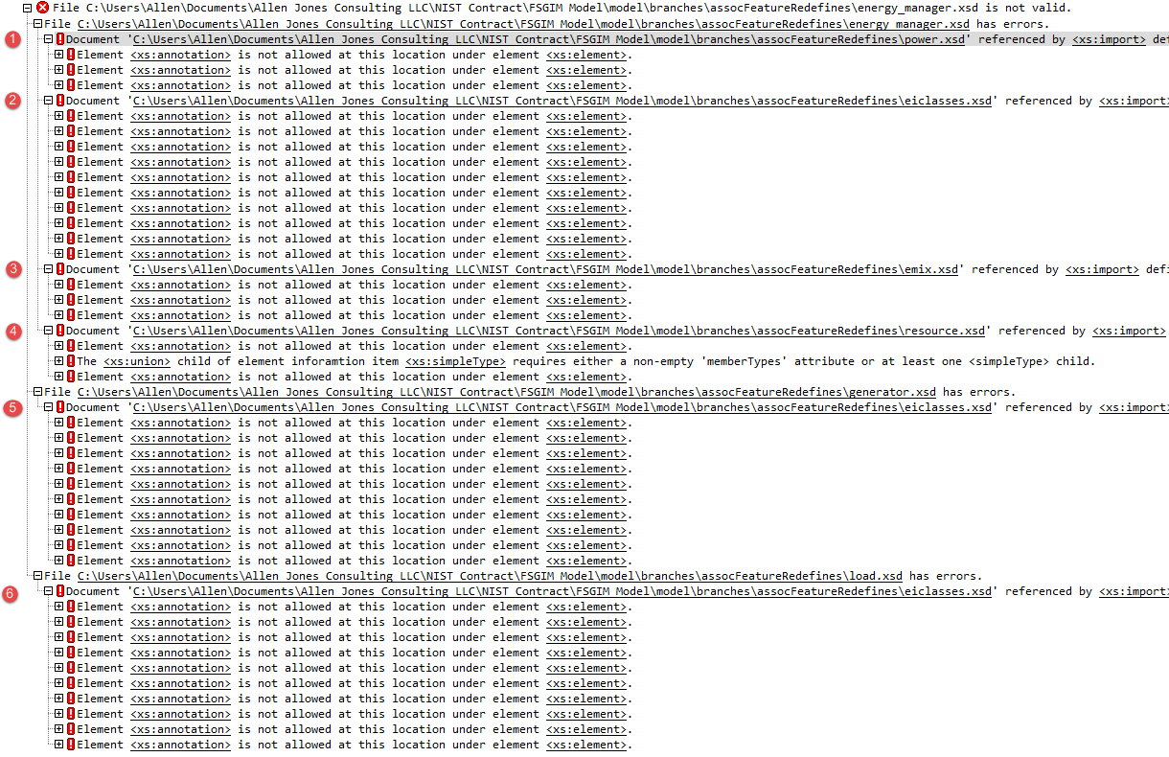When single clicking on the lines labeled ❶,❷,❸, or ❹ above, XMLSpy brings up a dialog box indicating that it has changed the target file, but does not specify what the changes are. Comparisons of the schema files before and after clicking on the lines mentioned above shows that the differences are due to the placement of the annotations for various elements. Once ❷ had been clicked, clicking on ❺ or ❻ did not generate the same dialog box because the eiclasses.xsd file had already been changed when ❷ was clicked.

The files that were modified in this initial round were power.xsd, eiclasses.xsd, emix.xsd, and resource.xsd. Saving each of these files generates the following warning message:

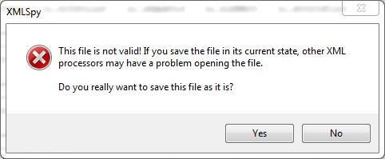

"Yes" was selected for each of the files, and then schema was revalidated. This yielded another set of annotation-related errors in emix-terms.xsd. XMLSpy was then allowed to automatically make changes to this file and the schema was revalidated. This yielded one final annotation-related error in resource.xsd. Repeating the process cleared this error and no more annotation related errors were found.

In an effort to eliminate the need to edit the OASIS schema files to move the annotations each time a new schema was created, a series of experiments was undertaken to find the cause for the incorrectly placed annotations. For each attribute that caused a problem, another attribute of the same type and multiplicity was added to the same class and the schema files were regenerated. If the schema for the new attribute did not require any edits but the schema for the old attribute did require an edit, then the properties of the two attributes were compared in Enterprise Architect. In each case where there were annotation problems, tagged values existed in the problematic attributes that were not present in the attributes that did not have a problem.

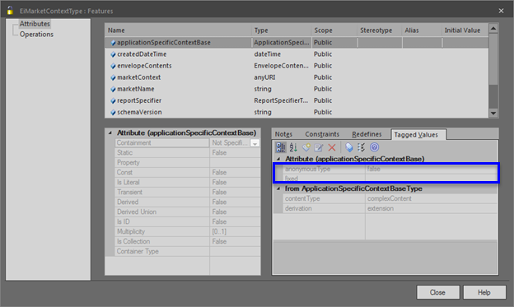

Figure - Problematic Tagged Values

In these cases, the problematic tagged values were removed and the schema was regenerated. In some cases, this caused the problem to move to a new location in the schema file. In these cases, the process was repeated until it was no longer necessary to modify the OASIS schema files in order to get them to validate.

The attributes that needed to be edited in this way were:

* ArrayOfSignals.eiEventBaseline in eiclasses.xsd
* PayloadPriceType.price in eiclasses.xsd
* EiMarketContextType.applicationSpecificContextBase in eiclasses.xsd
* EiMarketContextType.reportSpecifier in eiclasses.xsd
* MarketGranularityType.measurementQuality in emix-terms.xsd
* EmixOptionType.optionType in emix.xsd
* PowerResponseType.recoveryRamp in resource.xsd
* PowerResponseType.stagingRamp in resource.xsd.

## Remapping of Primitive Types to XSD Schema Types

Early attempts to validate the schema resulted in a large number of errors. (See Appendix A.1, Second Round of Schema Generation Errors.) Many of these errors were of the form "'X' must refer to an existing element" where 'X' was one of the FSGIM primitive types. This was addressed by downloading the XSDDataTypes package from <http://www.sparxsystems.com/downloads/profiles/XSDDataTypes.xml> and install it from the main menu into the NIST_Model package by selecting Publish | Model Exchange | Import XMI using the settings shown in Figure 2 - XMI Import Dialog Box.

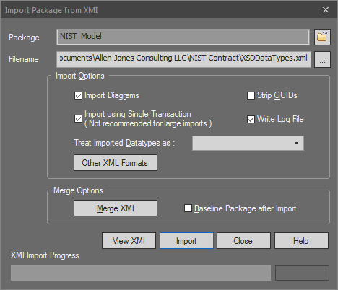

Figure - XMI Import Dialog Box

The FSGIM primitives in the model were then changed on an attribute by attribute basis to the XSDDataTypes according to the following mapping:

| **FSGIM Type** | **XSDDataType** |
| --- | --- |
| AnyType | <<XSDsimpleType>> anyType |
| AnyURI | <<XSDsimpleType>> anyURI |
| Boolean | <<XSDsimpleType>> boolean |
| Date | <<XSDsimpleType>> date |
| DateTime | <<XSDsimpleType>> dateTime |
| DateTimeInterval | This was left unchanged since this is built up from other primitives. |
| Duration | <<XSDsimpleType>> duration |
| GlobalID | <<XSDsimpleType>> string[2] |
| Integer | <<XSDsimpleType>> integer |
| LocalDateTime | <<XSDsimpleType>> dateTime |
| LocalDateTimeInterval | This was left unchanged since this is built up from other primitives. |
| Real | <<XSDsimpleType>> float |
| String[3] | <<XSDsimpleType>> string |
| UTCDateTime | <<XSDsimpleType>> dateTime |
| UTCDateTimeInterval | This was left unchanged since this is built up from other primitives. |

Table - Mapping of FSGIM Primitives and Common Classes to XSD Types

Following this change, the unused old FSGIM primitives were removed from the model as shown in Figure 3 - Modified Common Primitive Types, Classes and Enumerations Package.

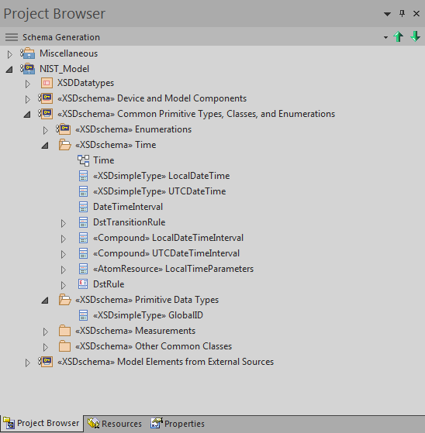

Figure - Modified Common Primitive Types, Classes and Enumerations Package

Default Namespaces and Prefixes were then added to the Time package and the Primitive Data Types packages as shown in Figure 4 - Added Namespaces and Namespaces since they no longer contain elements that the schema generator treats as true primitives, i.e., things that cannot be traced back any further when trying to generate schema based on the W3C primitives.

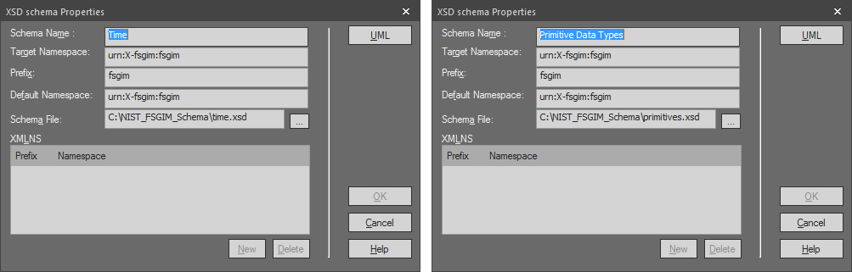

Figure - Added Namespaces and Prefixes

## Revised Treatment of Enumerations

All enumerations in the model were stereotyped as <<enumeration>>. In addition, the <<CodeList>> stereotype was removed from the enumerations shown in Appendix A.2, "Elimination of <<CodeList>> Stereotype" since this stereotype was preventing the schema from validating.

## Revised Treatment of Redefines

The most widespread change to the schema relates to the handling of redefined attributes and associations. The approach used in the Task 2 deliverable was to rename the redefined attribute or association so that Enterprise Architect could generate a valid schema. This proved to be undesireable for a long-term solution. The alternate approach shown in Figure 5 - UML Style Redefines and Figure 6 - XSD Style Redefines was adopted instead.



Figure - UML Style Redefines

Figure 5 shows a typical UML style of redefines. This style is used throughout the FSGIM, including in the Measurement model, the Aggregation model, and the Weather model.



Figure - XSD Style Redefines

In Figure 6, there is an extra class inserted between Class1 and Class3. This class may only contain the attributes and associations that are also present in its parent or a subset of these attributes and associations. Any attributes inherited from the parent must be included again in this class and these attributes must be redefinitions of the same attributes that are in the parent class. This class has a name with the form "Class3Restrictions" to show that it is a restriction of the original Class3. The association that existed between Class3 and Class4 in Figure 5 is then moved so that it goes from Class3Restrictions to Class4. In addition, <<XSDRestriction>> stereotypes are added between Class1 and Class3Restrictions and between Class2 and Class4.

In some cases, this transformation had to be applied in an iterative manner. For example, assume that:

* Figure 5 has two additional classes named Class6 and Class7 and;
* There is an association Class2🡪Class6 similar to the association Class1🡪Class2, and:
* There is an association Class4🡪Class7 similar to the association Class3🡪Class4,

then Figure 6 would need to have an additional class, Class4Restrictions, similar to the Class3Restrictions.

This same general pattern was applied throughout the model. Illustrative examples of this transformation are shown in Appendix A.3, "Task 2 Representation of Real Power" and Appendix A.4, "Task 6 Representation of Real Power" and in Appendix A.5, "Task 2 Representation of DemandAggregation" and Appendix A.6, "Task 6 Representation of DemandAggregation".

A variaton of this transformation was also applied to the Sequences and Intervals model and the Energy Router model. Under this variation, the UML model shown in Figure 7 was transformed into the version shown in Figure 8.



Figure - Variation of the Redefines Problem - UML Version



Figure - Variation of the Redefines Problem - XSD Version

An example of this type of transformation is shown in Appendix A.9, "Modifying GluonType to Allow for Schema Validation."

### Standard Aggregations

The Standard Aggregations revealed another variation on the basic "redefines" pattern. The model as it existed before the pattern was applied appears in Figure 9 - NetDemandAggregation Before Redefines Modification.



Figure - NetDemandAggregation Before Redefines Modification

In "Figure 10 - NetDemandAggregation After Redefines Modification," a NetDemandAggregationRestrictions class has been added to the model and the redefined attributes in NetDemandAggregation have been moved into this new class. The association from NetDemandAggregation to PowerMeasurementsSetRestrictions has also been changed so that it originates from this new class. Finally, an <<XSDRestriction>> has been applied to the generalization connector between MeasurementSet and Measurement, and redefined attributes have been added to MeasurementSet and the redefined arrangement that already existed between Measurement and PowerMeasurementSetRestrictions.



Figure - NetDemandAggregation After Redefines Modification

All of the other Standard Aggregations followed this same pattern with the exception of ThermalEnergyStoredAggregation. Unlike the other Standard Aggregations, ThermalEnergyStoredAggregation's aggregateQuantity was not a child of MeasurementSet, although it was a child of MeasurementSet's parent, Measurement. This distinction was enough to prevent the schema from validating. To work around this problem, a new ThermalEnergyMeasurementsSet containing the old EnergyThermalQuantity was created as shown in Figure 11 - New ThermalEnergyMeasurementsSet. This allowed the ThermalEnergyStoredAggregation to follow the same pattern that was used by the other Standard Aggregations.



Figure - New ThermalEnergyMeasurementsSet

## OASIS Schema Modifications

There were a number of issues with the OASIS schema that initallly prevented the schema from validating. These are listed below:

### Tagged Value "anonymousRole" Set to True

Several attributes within classes in the OASIS schema had their "anonymousRole" Tagged Value set to "true". These were changed to "false" as shown in Figure 12 - Setting "anonymousRole" to "false".

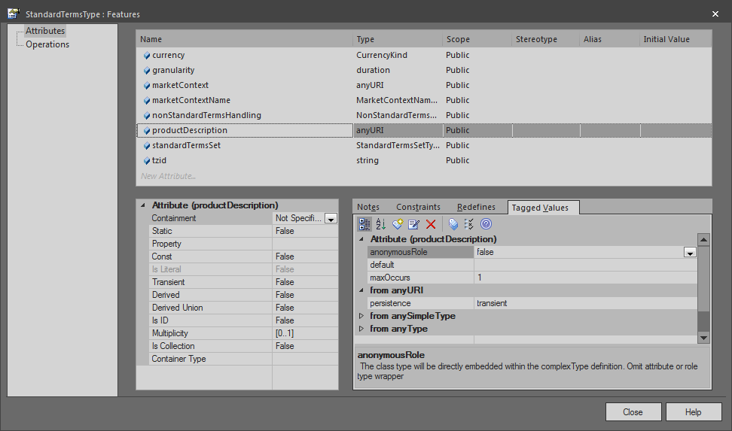

Figure - Setting "anonymousRole" to "false"

The affected attributes were:

| **Class** | **Attribute** |
| --- | --- |
| EiEventBaselineType | baselineID |
| EiTargetType | groupID |
| EiTargetType | resourceID |
| EiTargetType | venID |
| EmixOptionType | side |
| MeterAssetType | mrid |
| PayloadEmixType | productDescription |
| PayloadProductType | productDescription |
| PowerQualityWarrantType | measurementProtocol[4] |
| PowerQualityWarrantType | qualityType |
| PowerResponseType | recoveryRamp |
| PowerResponseType | stagingRamp |
| ResourceDescriptionType | mrid |
| SpecifierPayloadType | readingType |
| StandardTermsSetType | side |
| StandardTermsType | productDescription |

Table - OASIS Classes Requiring "anonymousRole" Edits

### Replacement of UML Unions with <<XSDUnions>>

The OASIS model from the FSGIM included several elements that had been stereotyped as <<Union>> as shown in Figure 13 - Original <<Union>> Representation. The UML approach that was used to represent these unions was inconsistent with the approach needed for XSD unions as shown in Figure 14 - New <<XSDunion>> Representation and these unions had to be converted. The technique for creating XSD unions is different than the technique used to show inheritance with classes. The XSD union technique is covered in Appendix A.8, "Creating an <<XSDUnion>>"



Figure - Original <<Union>> Representation



Figure - New <<XSDunion>> Representation

## Other Changes Related to Issues with the Original FSGIM Model

Several issues were found in the original FSGIM model. These items were corrected in the model used for this project and tickets will be generated for the ASHRAE 201 committee to address. These issues are shown in Appendix A.7, "Issues with the Original FSGIM Model".

## Enhancements to the Schema

### Setting the "pattern" Value for GlobalID

A pattern restriction of "^\{?[a-fA-F\d]{8}-([a-fA-F\d]{4}-){3}[a-fA-F\d]{12}\}?$" was applied to GlobalID by setting the "pattern" value for GlobalID as shown in Appendix A.10, "Applying Pattern Restrictions". This restricts the string to values that are in the form of a GUID. The value chosen for the restriction was based on <https://stackoverflow.com/questions/687884/what-is-the-correct-way-of-using-the-guid-type-in-a-xsd-file>.

### Applying the "fixed" Tag to Roles

The FSGIM has a number of associations where the enumeration pointed to by the association is restricted to a certain value. An example of this is shown in Figure 15 - Example of Restrictions on a Role's Attributes where the "uom" role is restricted for each of the children of AbstractMeasure.



Figure - Example of Restrictions on a Role's Attributes

For each of the constrained roles, a "fixed" tag was used to set the required value. The process for doing this is shown in Appendix A.11, "Applying Fixed Restrictions."

## Conversion to Atom Resources

Classes that already inherit from IdentifiedObject are atom resources.

### Step 1 - Color Coding

These atom resource classes were given a yellow background as shown in Figure 16 - Conversion to Atom Resources - Step 1.



Figure - Conversion to Atom Resources - Step 1

The pseudo-classes "Child of IdentifiedObject" and "Child of FSGIMIdentifiedObject" are meant as substitutes for all of the many classes that inherit from these classes.

### Step 2 - Common Root Class

To simplify the model, it is necessary for everything that is a resource to inherit from one common class. Initially, it would appear that this class would be IdentifiedObject, but FSGIMIdentifiedObject has a constraint on IdentifiedObject. That constraint is the multiplicity for the Names role from IdentifiedObject to Name must be 0 for anything that is an FSGIMIdentifiedObject. For this reason, we decided to make FSGIMIdentifiedObject the common parent for all resources. There are several things that happen as a result of this decision:

* FSGIMIdentifiedObject picks up the mRID attribute of its parent.
* Children of IdentifiedObject now inherit from FSGIMIdentifiedObject. (The affected classes were changed from a thin black border with a yellow fill to a bold orange border with a yellow fill.)
* The association between IdentifiedObject and Name went away. This association was used to handle tagging which is handled differently in the FSGIM.



### Step 3 - Additional Atom Resources

In addition to the classes that are already atom resources, NIST and ESTA discussed what other classes should become atom resources. The identifed classes, which are shown in orange in Appendix A.12, "Newly Added Atom Resources", were made to inherit from FSGIMIdentiedObject. In some cases, there were other classes that inherited from these new atom resource classes. These additional classes are not shown in Appendix A.12 but were also highlighted in orange in the model.

### Step 4 - Assignment of Stereotypes

Classes that were Atom Resources were stereotyped as <<AtomResource>>. Associations from one atom resource to another atom resource had their target roles stereotyped as <<AtomLink>> Associations from non-atom resources to atom resources were stereotyped as <<hRef>>. Attributes were handled similarly to their equivalent assocation.

### Step 5 - Creation of "Before" Diagrams

Individual diagrams of each of the resources were then made before converting to atom links. Each of the 125 resources in the attached pdf file is shown in a separate diagram. The diagrams are bookmarked as Package-Resource and each diagram shows all of the classes that were connected to that resource before converting to atom links.



### Step 6 - Making the Conversion

* Any associations that were stereotyped as <<AtomLink>> were deleted.
* Any attributes that were stereotyped as <<AtomLink>> were deleted.
* Any <<href>> attributes that were not already of type <<anyURI>> were changed to <<anyURI>>.
* New <<href>> attributes were created to replace deleted <<hRef>> associations.

### Step 7 - Creation of "After" Diagrams

The same diagrams that were saved as a pdf file in 'Step 5 - Creation of "Before" Diagrams' were saved again and are attached below. This allows for a "before" and "after" comparison that indicates where explicit associations have been replaced with atom links and href links.



### Step 8 - Creation of Fictitious FSGIMAtomLink and FSGIMWeatherAtomLink Classes

When the weather-related schema files were recreated after having completed the previous steps of this section, it was found that there were quite a few weather-related schema files that never got generated. This was due to the fact that after removing the associations that were atom links and after having the hrefs refer to anyURI instead of the original classes, there were some parts of the weather model that no longer had a connection to the FSGIMWeather package. This caused those schema files not to be generated when the schema files for the FSGIMWeather package were generated. To avoid this problem, two new packages were created along with two new classes, FSGIMWeatherAtomLink and FSGIMAtomLink as shown in Figure 17 - Fictitious FSGIMAtomLink and FSGIMWeatherAtomLink Classes and Associated Packages.

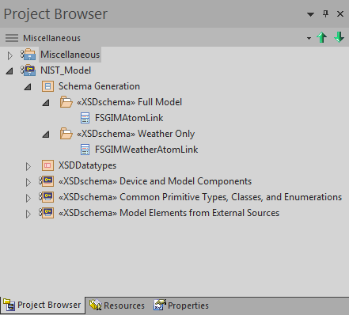

Figure - Fictitious FSGIMAtomLink and FSGIMWeatherAtomLink Classes and Associated Packages

These two fictitious classes were then connected to the atom resources as shown in the attached pdf.



An excerpt of this diagram is shown in Figure 18 - Excerpt of Task 6 FSGIMAtomResource.pdf to illustrate how these two classes pull in the rest of the atom resources.

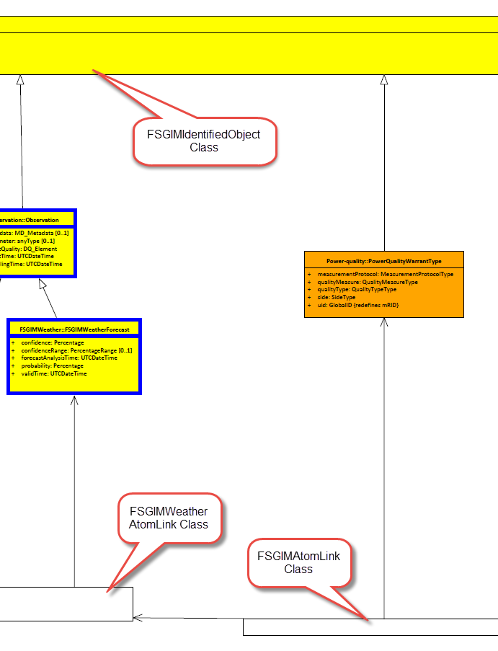

Figure - Excerpt of Task 6 FSGIMAtomResource.pdf

Clicking on the <<XSDschema>> Weather Only package in the Project Browser and generating a schema for that package will thus cause schema files to be generated for the whole FSGIM Weather model. Clicking on the <XSDschema>> Full Model package in the Package Browser and generating a schema for that package will cause schema files to be generated for the entire FSGIM model. The two fictitious classes, FSGIMWeatherAtomLink and FSGIMAtomLink, are only used to force the creation of all the necessary schema files.

## Profiling of the Model

### Remove Rulesets

The FSGIM uses Rulesets to define the behavior of the Standard Aggregations. Each Standard Aggregation Ruleset defines the behavior of its corresponding Standard Aggregation. A given type of Standard Aggregation always has the same prescribed behavior. It was agreed with NIST that since a given type of Standard Aggregation always has the same prescribed behavior, the corresponding Ruleset could be inferred and it was not necessary to explicitly include these rulesets in the profiled model.

Section 15.4 of Cleaned-up Full Model Schema Generation Problems.docx.

### Mapping to mRID for Select Classes

Several of the classes that had been newly changed to inherit from FSGIMIdentifiedObject already had attributes that were of type GlobalID. NIST and ESTA reviewed these classes to see if any of these attributes should be made "redefines" of FSGIMIdentiedObject's mRID.

It was decided that the attributes stereotyped as <<Resource>> in 'Figure 19 - GlobalIDs that will become "redefines" of mRID' qualified.



Figure - GlobalIDs that will become "redefines" of mRID

'Figure 20 - GlobalIDs after being "redefined"' shows the result after this change was made.



Figure - GlobalIDs after being "redefined"

Later it was decided that EndDeviceAssetType.mrid should also redefine mRID.

### Reducing the Number of Resources

While looking at how to reduce the total number of resources in the profiled model, it was found that some of the resources were abstract and had only one child. In these cases, the child class was given all of the attributes and associations of the parent and the parent was removed from the model. In addition, in *some* similar circumstances where the parent class was not abstract, it might also be possible to eliminate the parent class and use the child class instead. The candidates for this simplification and notes as to the changes that were made or declined are listed in Appendix A.13, "Merged Classes".

### Eliminating Weather Resources that Are not Part of Conformance Blocks

To further reduce the large number of atom resources in the model, it was agreed with NIST that weather-related resources that were not a part of the FSGIM weather-related Conformance Blocks could be removed from the model. This eliminated resources are:

The eliminated resources are:

* WindLayer
* Convection
* RadioactiveCloud
* Turbulence
* Thunderstorm
* Windshear
* Icing
* VolcanicAshCloud
* MountainWave
* Hydrometeor
* MountainObscuration
* VolcanicActivity
* Shower
* Lithometeor
* TropicalCyclone
* OtherPhenomenon
* MotionVector
* AerodromeWx
* HorizontalVisibility
* Sea
* AreaOfInterest
* SurfaceDeposit
* Volcano

### Removing Empty Directories

As a result of the various simplifications, some packages became empty. These were removed from the model. The list of removed packages is as follows:

* NIST_Model.Model Elements from External Sources.IEC61850.IEC61850_7_2.BasicDAs
* NIST_Model.Model Elements from External Sources.WXXM.WX.WX_Features
* NIST_Model.Model Elements from External Sources.WXXM.WX.WX_Observation
* NIST_Model.Model Elements from External Sources.WXXM.WX.WX_MotionVector
* NIST_Model.Model Elements from External Sources.WXXM.WX.WX_Forecast
* NIST_Model.Model Elements from External Sources.WXXM.WX.WX_Features
* NIST_Model.Model Elements from External Sources.WXXM.AVWX.AVWX_Phenom_Wind
* NIST_Model.Model Elements from External Sources.WXXM.AVWX.AVWX_Phenom_Volcanic
* NIST_Model.Model Elements from External Sources.WXXM.AVWX.AVWX_Phenom_TropicalCyclone
* NIST_Model.Model Elements from External Sources.WXXM.AVWX.AVWX_Features

### Reducing the Number of Namespaces

In order to flatten the schema, it was desireable to have fewer namespaces. It was initially determined that we needed a minimum of two.

Almost everything will be set up as follows:

* Target namespace: urn:X-fsgim:fsgim
* Prefix: fsgim
* Default Namespace: urn:X-fsgim:fsgim

There were two classes named Observation, so the one in WXXM/WX/WX_Observation[5] would be set up as follows:

* Target namespace: urn:X-fsgim:fsgim2
* Prefix: fsgim2
* Default Namespace: urn:X-fsgim:fsgim2

After attempting to validate the resulting schema, it was found that there were also two classes named PowerRampSegmentType - one in the Load and one in EMIX PR04/Resource. To minimize the number of elements that are in anything other than the fsgim namespace, a second package was created under Resource called "Resource2" and the PowerRampSegmentType Class that had been in the Resource package was moved to this package. It was set up to be in the fsgim2 namespace. The schema file for this package is resource2.xsd.

In the diagram below,

* The package labeled 1 has no namespaces assigned to it. There are no elements that are defined in these packages. They only contain drawings, so they do not need namespaces.
* The package labeled 2 has no namespace assigned to it because there are no elements directly in this package, only in the subpackages.
* The package labeled 3 does not have a namespace because this is the EA provided package that allows us to connect things to the XML schema xs namespace. We do not want to override that.
* The two packages labeled 4 are in the fsgim2 namespace.
* All other packages and subpackages use the fsgim namespace.

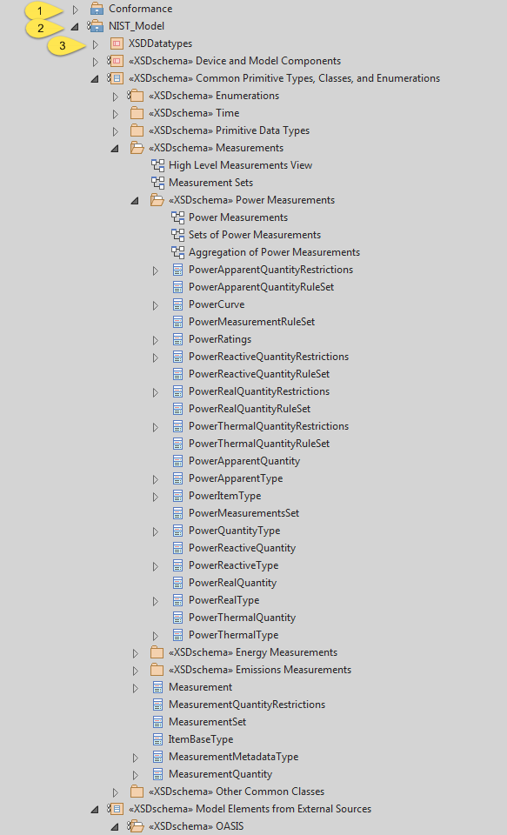 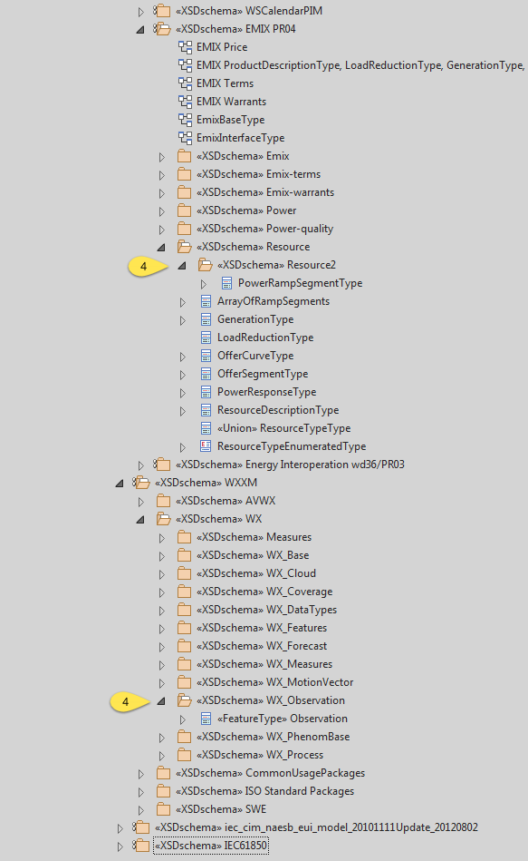

## Manual Schema Editing

In some cases, such as the MeasurementQuantity class, the ordering of the elements in the schema conflicted with the ordering of the elements of the parent of that class. An attempt was made to use the "position" tagged value of these elements to correct the problem, but the results were inconsistent. As a result, the schema for these child classes would not validate. In these cases, it was necessary to manually edit the resulting schema so as to place the elements in the correct order. These edits are shown in Appendix A.14, "Manual Schema Edits for Ordering of Elements."

1. Supplemental Information
   1. Second Round of Schema Generation Errors

The attached file contains the initial schema generation errors after having resolved the annotation errors. (The lines that show the annotations for each element have been removed from the error messages to conserve space.)



* 1. Elimination of <<CodeList>> Stereotype

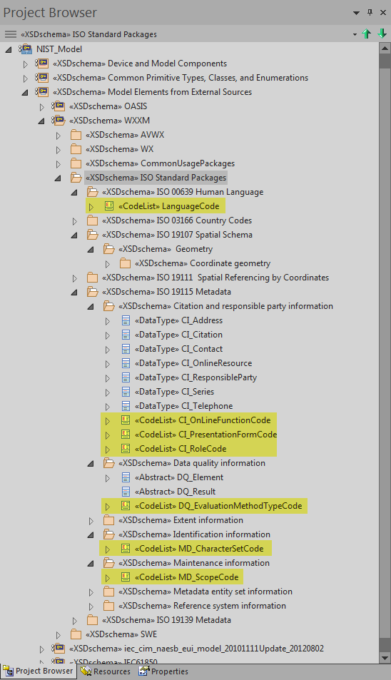

Figure - CodeList Stereotyped Packages

* 1. Task 2 Representation of Real Power



Figure - Task 2 Representation of Real Power

* 1. Task 6 Representation of Real Power



Figure - Task 6 Representation of Real Power

* 1. Task 2 Representation of DemandAggregation





Figure - Task 2 DemandAggregation

* 1. Task 6 Representation of DemandAggregation





Figure - Task 6 DemandAggregation

* 1. Issues with the Original FSGIM Model

The following issues were found in the original FSGIM model and tickets have either been issued or will be issued so that the responsible committee may address them.

* + 1. PowerThermalQuantityRuleset is Missing Initializers (Ticket 679)

All of the standard aggregation rulesets except the PowerThermalQuantityRuleset have predefined values for name, nameType, and nameTypeAuthority. PowerThermalQuantityRuleset needs these predefined values as well. Specifically, the attributes and their proposed values are:

* name = PowerThermalQuantityRuleset
* nameType = Measurement Rulesets
* nameTypeAuthority = ASHRAE 201 Standard
  + 1. Need to change defined value for watts per square meter (Ticket 680)

The FSGIM UnitSymbolKind says "Only VA, W, var, VAh, Wh, varh, Btu, J, therm, BtuPerh, g, gPerM3, gPerS, m, mPerS, WPerM2, rad, sb, pa, and degK are normative for the FSGIM standard. The enumerated values of VA, W, var, VAh, Wh, and varh were changed from their original NAESB values of vA, w, vAr, vAH, wH, and vArH to make them consistent with the standard SI abbreviations for these units."

The UnitSymbolKind currently lists watts per square meter as "wPerM2" instead of "WPerM2" as stated in the description for UnitSymbolKind. It needs to be "WPerM2" to be consistent with the decision to make enumerated values match the standard SI abbreviations for these units.

* + 1. AbstractObject Class should be abstract (Ticket 681)

In the WXXM weather model, the result of an Observation is an AbstractObject. The AbstractObjectClass, in turn, serves as the parent, grandparent, etc. of many other concrete classes such as Precipitation, TropicalCyclone, etc. It is these concrete classes that are the actual results of the Observation.AbstractObject, as its name implies, is really meant to be an abstract version of all of these concrete child classes. As such, it should be identified as "abstract" in the UML model. After discussing this with Marty Burns, he agreed.

The AbstractObject Class can be found at "Model/Model Elements from External Sources/WXXM/CommonUsagePackages/ISO 19136 Annex D.3/AbstractObject."

* + 1. The centre attribute of TropicalCyclone duplicates the centre association (Ticket 682)

TropicalCylcone has an attribute named centre of type DirectPosition. It also has an association to DirectPosition named "centre." These both have the same description (with the exception of a British spelling in one and an American spelling in the other). After discussing this with Marty, it was decided that we should delete the attribute.

* + 1. Some Elements in the Weather Model are Never Referenced (Ticket 683)

There are several elements in the WXXM model that are never actually used in the FSGIM. These should be removed from the model. In the cases where this results in an empty package, the empty package should also be removed from the model. The affected elements are as follows:

* WXXM.AVWX.AVWX_AreaOfInterestWx.SeaState
* WXXM.AVWX.AVWX_DataTypes.ContaminationExtent
* WXXM.AVWX.AVWX_Measures.QPressure
* WXXM.AVWX.ICAO_Annex_3_Base.NextAdvisoryText
* WXXM.WX.WX_Coverage.AbstractCoverage
* WXXM.WX.WX_Coverage.AreaCoverage
* WXXM.WX.WX_Coverage.DiscreteCoverage
* WXXM.ISO Standard Packages.ISO 19115 Metadata.Extent information.EX_Extent
* WXXM.SWE.OM2_Sampling.samplingBase.SamplingFeature
  + 1. IEC 61850 SequenceDirectionENS Schema Error

The problem where a newly created SequenceDirectionENS enumeration was duplicating the name of a no longer used SequenceDirectionENS Class was discussed with NIST because it appeared to go beyond the "light edits" approach that the SPC201P committee had previously agreed to. The class contained the same enumerated values, but also contained several other attributes that could have easily been left in *without* requiring the committee to pull in yet more classes. The decision was made to switch back to the class and delete the identically named enumeration. It was necessary to remove the specifically assigned integer values from the enumeration to keep with the SPC201P committee decision that the encoding of enumerated values was outside the scope of an abstract information model.

* + 1. Modification of Customer, CustomerAuthorisation, and MeterReading

The "name" attribute was removed from the Customer, CustomerAuthorisation, and MeterReading classes. All of these classes inherit from IdentifiedObject which has the exact same attribute, i.e., the attribute name, the attribute multiplicity, and the attribute description are identical. This makes the inclusion of this attribute in the child classes unnecessary.

* + 1. The attributes of DQ_Element have the multiplicities included as part of the attribute name

The attributes of DQ_Element have their multiplicities included as part of the attribute name. These multiplicities need to be removed from the attribute name and added to the multiplicity fields. In addition, DQ_Element.result has a type of DQ_Result and a multiplicity of [1..2] which means that it is required. DQ_Result is an abstract class with no children so it cannot be instantiated. It is apparently meant as an extension mechanism. Recommend changing the multiplicity of DQ_Result.result to [0..2].

* + 1. Some Information that is required by the FSGIM Weather model is not readily available

There are several attributes in the FSGIM Weather model that do not include zero as an allowable multiplicity value. This means that they are required. Some of the information corresponding to this information is not readily available, e.g. it is not provided by NOAA in their publicly available data. Specifically, the problematic attributes are:

| **Class** | **Attribute** | **Current Multiplicity** |
| --- | --- | --- |
| Forecast | confidenceRange | [1] |
| Observation | metadata | [1] |
| Observation | parameter[6] | [1] |
| AbstractPhenomenon | coverage | [1] |
| VerticallyBoundedPhenomenon | base | [1] |
| VerticallyBoundedPhenomenon | top[7] | [1] |

It is recommended that these multiplicities be changed to [0..1].

* 1. Creating an <<XSDUnion>> in Enterprise Architect
* In the EA Toolbox, click "More Tools…"

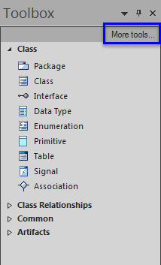

* Select "XML Schema".

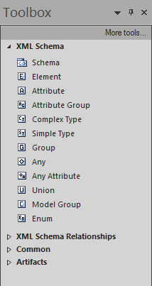

* Drag an instance of "Union" onto the screen.



* Add copies of the enumerations or classes that you want included in the union.



* Double-click on the Union to bring up its properties.

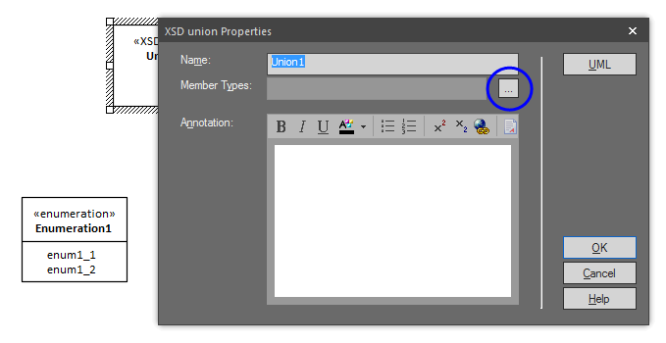

* Click the "…" next to Member Types.

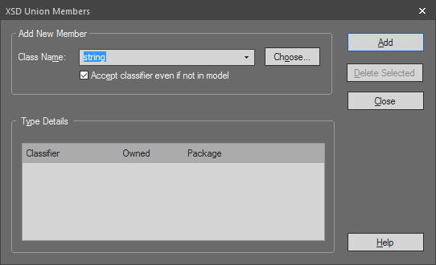

* Select XSD simple types using the dropdown list or click "Choose…" to select other elements from the model.

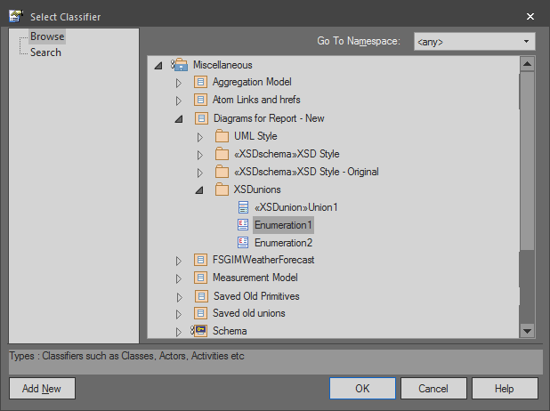

* Click "OK."

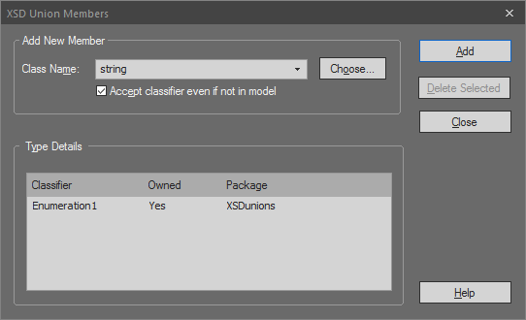

* Add additional union members as necessary.
* Once all union members are added, click Close in the XSD Union Members dialog box then click "OK" in the XSD union Properties dialog box.

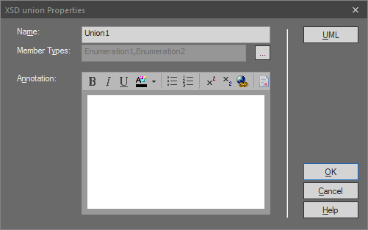



* 1. Modifying GluonType to Allow for Schema Validation

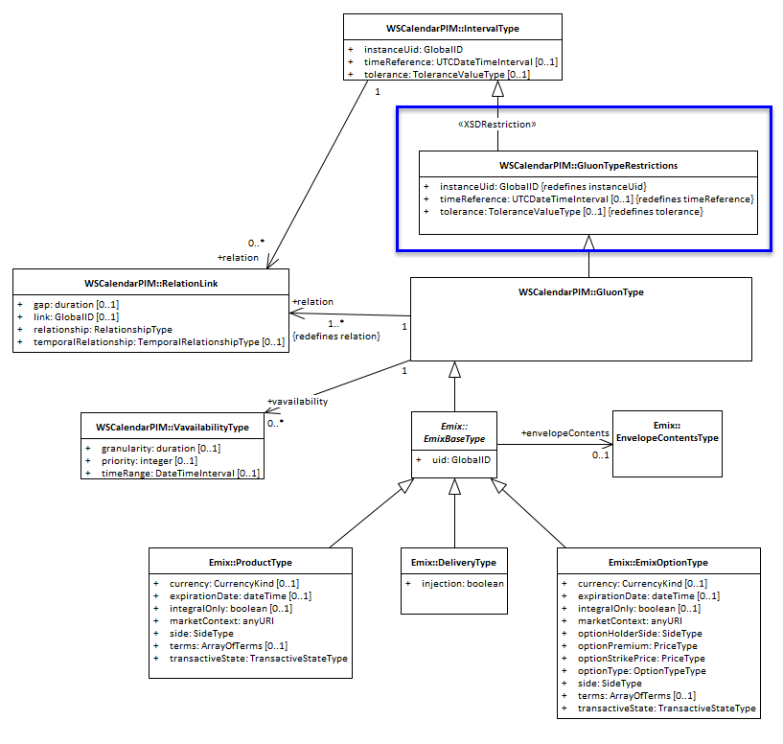

Figure - Modified GluonType

* 1. Applying Pattern Restrictions

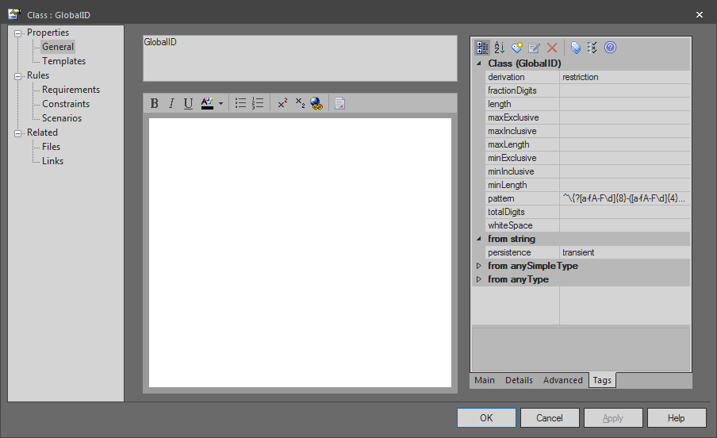

Figure - Pattern Restrictions

* 1. Applying Fixed Restrictions

To set the "fixed" tag on an association's role, bring up the connector's Properties dialog box. Click on General 🡪 Connector Target 🡪 Tags as shown in Figure 28 - Adding a Tag to a Role. Click on the Add Tag icon and set the "Tag" to "fixed" and the "Value" to the desired value.

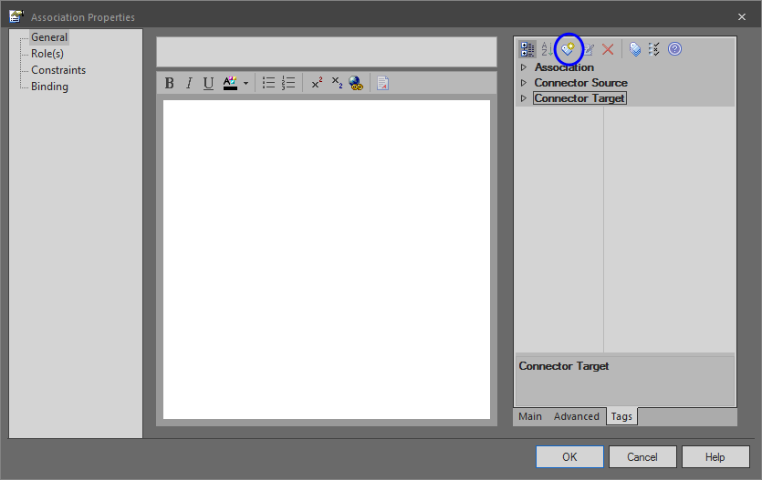

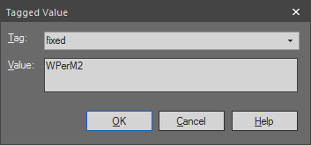

Figure - Adding a Tag to a Role

* 1. Newly Added Atom Resources



Figure - Newly Added Atom Resources

* 1. Merged Classes

The candidate classes for merging and notes as to the changes that were made or declined are as follows:[8]

* + 1. Precipitation



* + - 1. Atom links and hrefs before

|  |  |  |  |  |  |  |  |  |  |
| --- | --- | --- | --- | --- | --- | --- | --- | --- | --- |
| **Attribute or Association** | **Stereotype** | **Source Class Name** | **Source Class GUID** | **Attribute or Role Name** | **Attribute or Connector GUID** | **Multiplicity or Cardinality** | **Target Class Name** | **Target Class GUID** | **Association Type** |
| Association | AtomLink | Shower | {319408FD-E404-46fb-9A5A-3DA51373EC31} | contains | {E5B0108F-C62C-4d24-88DB-D637D7D6C153} | 0..* | Precipitation | {D714CEBD-A85F-4eee-9E42-7808C47182EC} | Association |
| Association | AtomLink | Thunderstorm | {52118551-6345-4a7b-AE8B-2D63231B2BFC} | contains | {02E7D181-8186-4e57-8299-C7611F8981C7} | 0..* | Precipitation | {D714CEBD-A85F-4eee-9E42-7808C47182EC} | Association |

* + - 1. Atom links and hrefs after

|  |  |  |  |  |  |  |  |  |  |
| --- | --- | --- | --- | --- | --- | --- | --- | --- | --- |
| **Attribute or Association** | **Stereotype** | **Source Class Name** | **Source Class GUID** | **Attribute or Role Name** | **Attribute or Connector GUID** | **Multiplicity or Cardinality** | **Target Class Name** | **Target Class GUID** | **Association Type** |
| Association | AtomLink | Shower | {319408FD-E404-46fb-9A5A-3DA51373EC31} | contains | {E5B0108F-C62C-4d24-88DB-D637D7D6C153} | 0..* | FSGIMPrecipitation | {E83ADD11-5836-412c-85FB-F066ACEFF55E} | Association |
| Association | AtomLink | Thunderstorm | {52118551-6345-4a7b-AE8B-2D63231B2BFC} | contains | {02E7D181-8186-4e57-8299-C7611F8981C7} | 0..* | FSGIMPrecipitation | {E83ADD11-5836-412c-85FB-F066ACEFF55E} | Association |

* + 1. AbstractReport



* + - 1. Atom links and hrefs before

|  |  |  |  |  |  |  |  |  |  |
| --- | --- | --- | --- | --- | --- | --- | --- | --- | --- |
| **Attribute or Association** | **Stereotype** | **Source Class Name** | **Source Class GUID** | **Attribute or Role Name** | **Attribute or Connector GUID** | **Multiplicity or Cardinality** | **Target Class Name** | **Target Class GUID** | **Association Type** |
| Association | AtomLink | AbstractReport | {6BECF9B8-1921-44c5-AD57-5A45E020530B} | wxObservation | {2BF60736-53C7-45be-9ADD-72C5505F69B8} | 1..* | Observation | {9BAE0BE0-BD9B-4270-A001-EA398079E6D5} | Association |
| Association | AtomLink | AbstractReport | {6BECF9B8-1921-44c5-AD57-5A45E020530B} | abstractAppliesTo | {C57DDB11-4C36-47bd-8D1D-0B0A5703103D} | 0..1 | Aerodrome | {940B1482-FDDD-4b2a-A103-ED2EF1B2D93F} | Association |
| Association | AtomLink | AbstractReport | {6BECF9B8-1921-44c5-AD57-5A45E020530B} | wxForecast | {4CBF78F6-F163-4908-BA91-94AE7CFB20A8} | 0..* | Forecast | {80B3EEAF-3A6F-4f39-8D52-D62FF88975D4} | Association |

* + - 1. Atom links and hrefs after

|  |  |  |  |  |  |  |  |  |  |
| --- | --- | --- | --- | --- | --- | --- | --- | --- | --- |
| **Attribute or Association** | **Stereotype** | **Source Class Name** | **Source Class GUID** | **Attribute or Role Name** | **Attribute or Connector GUID** | **Multiplicity or Cardinality** | **Target Class Name** | **Target Class GUID** | **Association Type** |
| Association | AtomLink | FSGIMWeatherReport | {27305A41-78F6-4148-A2F9-BD6A9AF4DD42} | wxObservation | {2BF60736-53C7-45be-9ADD-72C5505F69B8} | 1..* | Observation | {9BAE0BE0-BD9B-4270-A001-EA398079E6D5} | Association |
| Association | AtomLink | FSGIMWeatherReport | {27305A41-78F6-4148-A2F9-BD6A9AF4DD42} | abstractAppliesTo | {C57DDB11-4C36-47bd-8D1D-0B0A5703103D} | 0..1 | Aerodrome | {940B1482-FDDD-4b2a-A103-ED2EF1B2D93F} | Association |
| Association | AtomLink | FSGIMWeatherReport | {27305A41-78F6-4148-A2F9-BD6A9AF4DD42} | wxForecast | {4CBF78F6-F163-4908-BA91-94AE7CFB20A8} | 0..* | Forecast | {80B3EEAF-3A6F-4f39-8D52-D62FF88975D4} | Association |

* + 1. AbstractObject and AbstractGML



* + - 1. Atom links and hrefs before

|  |  |  |  |  |  |  |  |  |  |
| --- | --- | --- | --- | --- | --- | --- | --- | --- | --- |
| **Attribute or Association** | **Stereotype** | **Source Class Name** | **Source Class GUID** | **Attribute or Role Name** | **Attribute or Connector GUID** | **Multiplicity or Cardinality** | **Target Class Name** | **Target Class GUID** | **Association Type** |
| **Association** | **AtomLink** | **Observation** | **{37979978-011B-4ffe-882F-CB9CC2B4CD35}** | **abstractResult** | **{8F711C5A-3CE8-4619-A393-BF7488A5306F}** | **1** | **AbstractObject** | **{BCFD2C4B-2B9A-46b8-8363-C4129ACB70C3}** | **Association** |

* + - 1. Atom links and hrefs after

|  |  |  |  |  |  |  |  |  |  |
| --- | --- | --- | --- | --- | --- | --- | --- | --- | --- |
| **Attribute or Association** | **Stereotype** | **Source Class Name** | **Source Class GUID** | **Attribute or Role Name** | **Attribute or Connector GUID** | **Multiplicity or Cardinality** | **Target Class Name** | **Target Class GUID** | **Association Type** |
| Association | AtomLink | Observation | {37979978-011B-4ffe-882F-CB9CC2B4CD35} | abstractResult | {8F711C5A-3CE8-4619-A393-BF7488A5306F} | 1 | AbstractFeature | {932E6532-82C6-495b-B7E7-B117401264AA} | Association |

* + 1. AviationWx



* + - 1. Atom links and hrefs before

|  |  |  |  |  |  |  |  |  |  |
| --- | --- | --- | --- | --- | --- | --- | --- | --- | --- |
| **Attribute or Association** | **Stereotype** | **Source Class Name** | **Source Class GUID** | **Attribute or Role Name** | **Attribute or Connector GUID** | **Multiplicity or Cardinality** | **Target Class Name** | **Target Class GUID** | **Association Type** |
| Attribute | AtomLink | AviationWx | {F55DA892-FADC-4de0-A464-B5D21558A2BA} | horizontalVisibility | {68DA19AB-0830-4abe-9E55-32D779D0B80B} | 1..1 | HorizontalVisibility | {3AFEB04C-278B-4fa4-84D2-9D934CD8BA87} | NA |
| Attribute | AtomLink | AviationWx | {F55DA892-FADC-4de0-A464-B5D21558A2BA} | isDefinedFor | {B78C408C-FEF4-4dca-9415-6350E38C0212} | 1..1 | AbstractFeature | {932E6532-82C6-495b-B7E7-B117401264AA} | NA |
| Association | AtomLink | AbstractWxFeature | {B5164608-CB0E-4989-937F-3FA66309834F} | associatedAviationWxFeature | {B5298A8C-E9F9-416d-BF3B-D8D56B03E43D} | 0..1 | AviationWx | {F55DA892-FADC-4de0-A464-B5D21558A2BA} | Association |
| Association | AtomLink | Forecast | {80B3EEAF-3A6F-4f39-8D52-D62FF88975D4} | relatedAviationWxObservation | {4CE7D80E-3E81-49ae-868E-B0BD6E18DBC1} | 0..1 | AviationWx | {F55DA892-FADC-4de0-A464-B5D21558A2BA} | Association |

* + - 1. Atom links and hrefs after

|  |  |  |  |  |  |  |  |  |  |  |
| --- | --- | --- | --- | --- | --- | --- | --- | --- | --- | --- |
| **Attribute or Association** | | **Stereotype** | **Source Class Name** | **Source Class GUID** | **Attribute or Role Name** | **Attribute or Connector GUID** | **Multiplicity or Cardinality** | **Target Class Name** | **Target Class GUID** | **Association Type** |
| Attribute | AtomLink | | AerodromeWx | {4E8A4329-A9CB-484f-9EE5-63BD6B362B68} | horizontalVisibility | {68DA19AB-0830-4abe-9E55-32D779D0B80B} | 1..1 | HorizontalVisibility | {3AFEB04C-278B-4fa4-84D2-9D934CD8BA87} | NA |
| Attribute | AtomLink | | AerodromeWx | {4E8A4329-A9CB-484f-9EE5-63BD6B362B68} | isDefinedFor | {B78C408C-FEF4-4dca-9415-6350E38C0212} | 1..1 | AbstractFeature | {932E6532-82C6-495b-B7E7-B117401264AA} | NA |
| Association | AtomLink | | AbstractWxFeature | {B5164608-CB0E-4989-937F-3FA66309834F} | associatedAviationWxFeature | {B5298A8C-E9F9-416d-BF3B-D8D56B03E43D} | 0..1 | AerodromeWx | {4E8A4329-A9CB-484f-9EE5-63BD6B362B68} | Association |
| Association | AtomLink | | Forecast | {80B3EEAF-3A6F-4f39-8D52-D62FF88975D4} | relatedAviationWxObservation | {4CE7D80E-3E81-49ae-868E-B0BD6E18DBC1} | 0..1 | AerodromeWx | {4E8A4329-A9CB-484f-9EE5-63BD6B362B68} | Association |

* + 1. TREND



* + - 1. Atom links and hrefs before

|  |  |  |  |  |  |  |  |  |  |
| --- | --- | --- | --- | --- | --- | --- | --- | --- | --- |
| **Attribute or Association** | **Stereotype** | **Source Class Name** | **Source Class GUID** | **Attribute or Role Name** | **Attribute or Connector GUID** | **Multiplicity or Cardinality** | **Target Class Name** | **Target Class GUID** | **Association Type** |
| Association | AtomLink | TREND | {C00E8A15-1C18-459d-8456-FEE7989A820C} | forecast | {734CA2B5-F7DD-4956-9DA5-713F798ED7D0} | 0..* | Forecast | {80B3EEAF-3A6F-4f39-8D52-D62FF88975D4} | Association |

* + - 1. Atom links and hrefs after

|  |  |  |  |  |  |  |  |  |  |
| --- | --- | --- | --- | --- | --- | --- | --- | --- | --- |
| **Attribute or Association** | **Stereotype** | **Source Class Name** | **Source Class GUID** | **Attribute or Role Name** | **Attribute or Connector GUID** | **Multiplicity or Cardinality** | **Target Class Name** | **Target Class GUID** | **Association Type** |
| Association | AtomLink | FSGIMWeatherTrend | {C00E8A15-1C18-459d-8456-FEE7989A820C} | forecast | {734CA2B5-F7DD-4956-9DA5-713F798ED7D0} | 0..* | Forecast | {80B3EEAF-3A6F-4f39-8D52-D62FF88975D4} | Association |

* + 1. Aerodrome

 

* + - 1. Atom links and hrefs before

|  |  |  |  |  |  |  |  |  |  |
| --- | --- | --- | --- | --- | --- | --- | --- | --- | --- |
| **Attribute or Association** | **Stereotype** | **Source Class Name** | **Source Class GUID** | **Attribute or Role Name** | **Attribute or Connector GUID** | **Multiplicity or Cardinality** | **Target Class Name** | **Target Class GUID** | **Association Type** |
| Association | AtomLink | FSGIMWeatherReport | {27305A41-78F6-4148-A2F9-BD6A9AF4DD42} | abstractAppliesTo | {C57DDB11-4C36-47bd-8D1D-0B0A5703103D} | 0..1 | Aerodrome | {940B1482-FDDD-4b2a-A103-ED2EF1B2D93F} | Association |

* + - 1. Atom links and hrefs after

|  |  |  |  |  |  |  |  |  |  |
| --- | --- | --- | --- | --- | --- | --- | --- | --- | --- |
| **Attribute or Association** | **Stereotype** | **Source Class Name** | **Source Class GUID** | **Attribute or Role Name** | **Attribute or Connector GUID** | **Multiplicity or Cardinality** | **Target Class Name** | **Target Class GUID** | **Association Type** |
| Association | AtomLink | FSGIMWeatherReport | {27305A41-78F6-4148-A2F9-BD6A9AF4DD42} | abstractAppliesTo | {C57DDB11-4C36-47bd-8D1D-0B0A5703103D} | 0..1 | FSGIMWeatherArea | {E02E86BA-607E-40c0-9381-FF973D85E865} | Association |

* + 1. WX_Observation::Observation



* + - 1. Atom links and hrefs before

|  |  |  |  |  |  |  |  |  |  |
| --- | --- | --- | --- | --- | --- | --- | --- | --- | --- |
| **Attribute or Association** | **Stereotype** | **Source Class Name** | **Source Class GUID** | **Attribute or Role Name** | **Attribute or Connector GUID** | **Multiplicity or Cardinality** | **Target Class Name** | **Target Class GUID** | **Association Type** |
| Association | AtomLink | FSGIMWeatherReport | {27305A41-78F6-4148-A2F9-BD6A9AF4DD42} | wxObservation | {2BF60736-53C7-45be-9ADD-72C5505F69B8} | 1..* | Observation | {9BAE0BE0-BD9B-4270-A001-EA398079E6D5} | Association |

* + - 1. Atom links and hrefs after

|  |  |  |  |  |  |  |  |  |  |
| --- | --- | --- | --- | --- | --- | --- | --- | --- | --- |
| **Attribute or Association** | **Stereotype** | **Source Class Name** | **Source Class GUID** | **Attribute or Role Name** | **Attribute or Connector GUID** | **Multiplicity or Cardinality** | **Target Class Name** | **Target Class GUID** | **Association Type** |
| Association | AtomLink | FSGIMWeatherReport | {27305A41-78F6-4148-A2F9-BD6A9AF4DD42} | wxObservation | {2BF60736-53C7-45be-9ADD-72C5505F69B8} | 1..* | FSGIMWeatherObservation | {C74B8D8B-C8C1-4b1c-84F5-4EF5E4022C79} | Association |

* + 1. Forecast



* + - 1. Atom links and hrefs before

|  |  |  |  |  |  |  |  |  |  |
| --- | --- | --- | --- | --- | --- | --- | --- | --- | --- |
| **Attribute or Association** | **Stereotype** | **Source Class Name** | **Source Class GUID** | **Attribute or Role Name** | **Attribute or Connector GUID** | **Multiplicity or Cardinality** | **Target Class Name** | **Target Class GUID** | **Association Type** |
| Association | AtomLink | FSGIMWeatherReport | {27305A41-78F6-4148-A2F9-BD6A9AF4DD42} | wxForecast | {4CBF78F6-F163-4908-BA91-94AE7CFB20A8} | 0..* | Forecast | {80B3EEAF-3A6F-4f39-8D52-D62FF88975D4} | Association |
| Association | AtomLink | TREND | {C00E8A15-1C18-459d-8456-FEE7989A820C} | forecast | {734CA2B5-F7DD-4956-9DA5-713F798ED7D0} | 0..* | Forecast | {80B3EEAF-3A6F-4f39-8D52-D62FF88975D4} | Association |
| Association | AtomLink | Forecast | {80B3EEAF-3A6F-4f39-8D52-D62FF88975D4} | relatedWindLayerObservation | {55AF3E69-ACDC-45c6-8151-A3B6E380CC40} | 0..1 | WindLayer | {BD8A1D83-89CD-4458-BEF9-D0277D83EC3A} | Association |
| Association | AtomLink | Forecast | {80B3EEAF-3A6F-4f39-8D52-D62FF88975D4} | relatedVolcanicActivityObservation | {A4A00F54-540E-4293-850A-CBFAEE038D1F} | 0..1 | VolcanicActivity | {2B60FEF7-DDE4-44d5-8629-DEEC915959FB} | Association |
| Association | AtomLink | Forecast | {80B3EEAF-3A6F-4f39-8D52-D62FF88975D4} | relatedTropicalCycloneObservation | {60CDFFCA-5281-4600-A761-09C91A6F8499} | 0..1 | TropicalCyclone | {6C81E0D4-F560-4a54-8EAC-0EEF965BA5A8} | Association |
| Association | AtomLink | Forecast | {80B3EEAF-3A6F-4f39-8D52-D62FF88975D4} | relatedAviationWxObservation | {4CE7D80E-3E81-49ae-868E-B0BD6E18DBC1} | 0..1 | AerodromeWx | {4E8A4329-A9CB-484f-9EE5-63BD6B362B68} | Association |
| Association | AtomLink | Forecast | {80B3EEAF-3A6F-4f39-8D52-D62FF88975D4} | relatedTurbulenceObservation | {E7C46B55-F3E6-4252-AF2C-F7FA6FB7DF8F} | 0..1 | Turbulence | {06C18D14-D27E-4fbe-9E74-57B03A94972C} | Association |
| Association | AtomLink | Forecast | {80B3EEAF-3A6F-4f39-8D52-D62FF88975D4} | relatedSeaObservation | {FFC84F63-12FB-4c2b-A01C-1D61645F9156} | 0..1 | Sea | {B87B4704-7A53-463f-A356-1E8EFE47CDBC} | Association |
| Association | AtomLink | Forecast | {80B3EEAF-3A6F-4f39-8D52-D62FF88975D4} | relatedWindShearObservation | {AF3CC701-4B32-474b-8563-1D4D13B827A1} | 0..1 | WindShear | {5395B08F-7C6C-46f0-B9E4-B2B0A3A4B72A} | Association |
| Association | AtomLink | Forecast | {80B3EEAF-3A6F-4f39-8D52-D62FF88975D4} | relatedConvectionObservation | {5A8F36C6-7138-4228-B580-73461463295F} | 0..1 | Convection | {A7E65D72-5504-47b5-BB43-D7F7D9A7CDA9} | Association |
| Association | AtomLink | Forecast | {80B3EEAF-3A6F-4f39-8D52-D62FF88975D4} | relatedMountainWaveObservation | {23B487B9-5C1B-4e5b-BAA8-EF08306F8731} | 0..1 | MountainWave | {0F931461-2BA4-41a9-9700-32CE3072F99B} | Association |
| Association | AtomLink | Forecast | {80B3EEAF-3A6F-4f39-8D52-D62FF88975D4} | relatedIcingObservation | {4E272681-4071-4875-B948-3AE377D6EE68} | 0..1 | Icing | {4CD2F7BE-C1E5-4446-BE69-66535A62BFC6} | Association |
| Association | AtomLink | Forecast | {80B3EEAF-3A6F-4f39-8D52-D62FF88975D4} | relatedMountainObscurationObservation | {9C901E7F-BB65-4ef4-99B6-AD3E8025BEF2} | 0..1 | MountainObscuration | {67B7FB1A-2813-4680-B47C-F9D56B2BD844} | Association |
| Association | AtomLink | Forecast | {80B3EEAF-3A6F-4f39-8D52-D62FF88975D4} | relatedHorizontalVisibilityObservation | {1B119AE8-5B2E-4b20-A989-D1C90BC831B3} | 0..1 | HorizontalVisibility | {3AFEB04C-278B-4fa4-84D2-9D934CD8BA87} | Association |
| Association | AtomLink | Forecast | {80B3EEAF-3A6F-4f39-8D52-D62FF88975D4} | relatedObservation | {57125149-5858-4a73-8C97-853548692194} | 0..1 | AbstractFeature | {932E6532-82C6-495b-B7E7-B117401264AA} | Association |
| Association | AtomLink | Forecast | {80B3EEAF-3A6F-4f39-8D52-D62FF88975D4} | relatedSurfaceDepositObservation | {A6C43EDD-9B3F-48f9-87B6-9A63C3EACCD8} | 0..1 | SurfaceDeposit | {13672C90-668C-43f0-84DC-074C06ED07B5} | Association |
| Association | AtomLink | Forecast | {80B3EEAF-3A6F-4f39-8D52-D62FF88975D4} | relatedVolcanicAshCloudObservation | {72E38409-03C3-4caa-A5CA-46E561F8F995} | 0..1 | VolcanicAshCloud | {90D4BA61-97E2-4c38-A4C3-A3968DD7E08A} | Association |
| Association | AtomLink | Forecast | {80B3EEAF-3A6F-4f39-8D52-D62FF88975D4} | relatedAerodromeWxObservation | {394F01B3-78E8-4e72-AEA3-2D1E14AEF0DB} | 0..1 | AerodromeWx | {4E8A4329-A9CB-484f-9EE5-63BD6B362B68} | Association |

* + - 1. Atom links and hrefs after

|  |  |  |  |  |  |  |  |  |  |
| --- | --- | --- | --- | --- | --- | --- | --- | --- | --- |
| **Attribute or Association** | **Stereotype** | **Source Class Name** | **Source Class GUID** | **Attribute or Role Name** | **Attribute or Connector GUID** | **Multiplicity or Cardinality** | **Target Class Name** | **Target Class GUID** | **Association Type** |
| Association | AtomLink | FSGIMWeatherReport | {27305A41-78F6-4148-A2F9-BD6A9AF4DD42} | wxForecast | {4CBF78F6-F163-4908-BA91-94AE7CFB20A8} | 0..* | FSGIMWeatherForecast | {CFE38B12-3CE5-4c18-AD4E-0D2CF7594CA7} | Association |
| Association | AtomLink | TREND | {C00E8A15-1C18-459d-8456-FEE7989A820C} | forecast | {734CA2B5-F7DD-4956-9DA5-713F798ED7D0} | 0..* | FSGIMWeatherForecast | {CFE38B12-3CE5-4c18-AD4E-0D2CF7594CA7} | Association |
| Association | AtomLink | FSGIMWeatherForecast | {CFE38B12-3CE5-4c18-AD4E-0D2CF7594CA7} | relatedWindLayerObservation | {55AF3E69-ACDC-45c6-8151-A3B6E380CC40} | 0..1 | WindLayer | {BD8A1D83-89CD-4458-BEF9-D0277D83EC3A} | Association |
| Association | AtomLink | FSGIMWeatherForecast | {CFE38B12-3CE5-4c18-AD4E-0D2CF7594CA7} | relatedVolcanicActivityObservation | {A4A00F54-540E-4293-850A-CBFAEE038D1F} | 0..1 | VolcanicActivity | {2B60FEF7-DDE4-44d5-8629-DEEC915959FB} | Association |
| Association | AtomLink | FSGIMWeatherForecast | {CFE38B12-3CE5-4c18-AD4E-0D2CF7594CA7} | relatedTropicalCycloneObservation | {60CDFFCA-5281-4600-A761-09C91A6F8499} | 0..1 | TropicalCyclone | {6C81E0D4-F560-4a54-8EAC-0EEF965BA5A8} | Association |
| Association | AtomLink | FSGIMWeatherForecast | {CFE38B12-3CE5-4c18-AD4E-0D2CF7594CA7} | relatedAviationWxObservation | {4CE7D80E-3E81-49ae-868E-B0BD6E18DBC1} | 0..1 | AerodromeWx | {4E8A4329-A9CB-484f-9EE5-63BD6B362B68} | Association |
| Association | AtomLink | FSGIMWeatherForecast | {CFE38B12-3CE5-4c18-AD4E-0D2CF7594CA7} | relatedTurbulenceObservation | {E7C46B55-F3E6-4252-AF2C-F7FA6FB7DF8F} | 0..1 | Turbulence | {06C18D14-D27E-4fbe-9E74-57B03A94972C} | Association |
| Association | AtomLink | FSGIMWeatherForecast | {CFE38B12-3CE5-4c18-AD4E-0D2CF7594CA7} | relatedSeaObservation | {FFC84F63-12FB-4c2b-A01C-1D61645F9156} | 0..1 | Sea | {B87B4704-7A53-463f-A356-1E8EFE47CDBC} | Association |
| Association | AtomLink | FSGIMWeatherForecast | {CFE38B12-3CE5-4c18-AD4E-0D2CF7594CA7} | relatedWindShearObservation | {AF3CC701-4B32-474b-8563-1D4D13B827A1} | 0..1 | WindShear | {5395B08F-7C6C-46f0-B9E4-B2B0A3A4B72A} | Association |
| Association | AtomLink | FSGIMWeatherForecast | {CFE38B12-3CE5-4c18-AD4E-0D2CF7594CA7} | relatedConvectionObservation | {5A8F36C6-7138-4228-B580-73461463295F} | 0..1 | Convection | {A7E65D72-5504-47b5-BB43-D7F7D9A7CDA9} | Association |
| Association | AtomLink | FSGIMWeatherForecast | {CFE38B12-3CE5-4c18-AD4E-0D2CF7594CA7} | relatedMountainWaveObservation | {23B487B9-5C1B-4e5b-BAA8-EF08306F8731} | 0..1 | MountainWave | {0F931461-2BA4-41a9-9700-32CE3072F99B} | Association |
| Association | AtomLink | FSGIMWeatherForecast | {CFE38B12-3CE5-4c18-AD4E-0D2CF7594CA7} | relatedIcingObservation | {4E272681-4071-4875-B948-3AE377D6EE68} | 0..1 | Icing | {4CD2F7BE-C1E5-4446-BE69-66535A62BFC6} | Association |
| Association | AtomLink | FSGIMWeatherForecast | {CFE38B12-3CE5-4c18-AD4E-0D2CF7594CA7} | relatedMountainObscurationObservation | {9C901E7F-BB65-4ef4-99B6-AD3E8025BEF2} | 0..1 | MountainObscuration | {67B7FB1A-2813-4680-B47C-F9D56B2BD844} | Association |
| Association | AtomLink | FSGIMWeatherForecast | {CFE38B12-3CE5-4c18-AD4E-0D2CF7594CA7} | relatedHorizontalVisibilityObservation | {1B119AE8-5B2E-4b20-A989-D1C90BC831B3} | 0..1 | HorizontalVisibility | {3AFEB04C-278B-4fa4-84D2-9D934CD8BA87} | Association |
| Association | AtomLink | FSGIMWeatherForecast | {CFE38B12-3CE5-4c18-AD4E-0D2CF7594CA7} | relatedObservation | {57125149-5858-4a73-8C97-853548692194} | 0..1 | AbstractFeature | {932E6532-82C6-495b-B7E7-B117401264AA} | Association |
| Association | AtomLink | FSGIMWeatherForecast | {CFE38B12-3CE5-4c18-AD4E-0D2CF7594CA7} | relatedSurfaceDepositObservation | {A6C43EDD-9B3F-48f9-87B6-9A63C3EACCD8} | 0..1 | SurfaceDeposit | {13672C90-668C-43f0-84DC-074C06ED07B5} | Association |
| Association | AtomLink | FSGIMWeatherForecast | {CFE38B12-3CE5-4c18-AD4E-0D2CF7594CA7} | relatedVolcanicAshCloudObservation | {72E38409-03C3-4caa-A5CA-46E561F8F995} | 0..1 | VolcanicAshCloud | {90D4BA61-97E2-4c38-A4C3-A3968DD7E08A} | Association |
| Association | AtomLink | FSGIMWeatherForecast | {CFE38B12-3CE5-4c18-AD4E-0D2CF7594CA7} | relatedAerodromeWxObservation | {394F01B3-78E8-4e72-AEA3-2D1E14AEF0DB} | 0..1 | AerodromeWx | {4E8A4329-A9CB-484f-9EE5-63BD6B362B68} | Association |

* + 1. BaseWarrantType and QualityWarrantType



* + - 1. Atom links and hrefs before

|  |  |  |  |  |  |  |  |  |  |
| --- | --- | --- | --- | --- | --- | --- | --- | --- | --- |
| **Attribute or Association** | **Stereotype** | **Source Class Name** | **Source Class GUID** | **Attribute or Role Name** | **Attribute or Connector GUID** | **Multiplicity or Cardinality** | **Target Class Name** | **Target Class GUID** | **Association Type** |
| Attribute | AtomLink | QualityWarrantType | {D9540EB2-19B4-48be-A8E5-06A5909C57D9} | product | {16FB468E-8D4D-41bb-8B7A-C8DC6C2F3F2D} | 1..* | ProductType | {4F853FAA-4D0F-4c83-BDE1-9965BCB6BEBD} | NA |
| Association | href | EnvelopeContentsType | {C4F60409-49F0-4a50-8275-A2D0D36E3EE5} | warrants | {C251E3F5-F4A3-48ca-9705-98A121D21177} | 0..* | BaseWarrantType | {71977A8B-8349-4c3b-B76D-175CD537A1C5} | Association |

* + - 1. Atom links and hrefs after

|  |  |  |  |  |  |  |  |  |  |
| --- | --- | --- | --- | --- | --- | --- | --- | --- | --- |
| **Attribute or Association** | **Stereotype** | **Source Class Name** | **Source Class GUID** | **Attribute or Role Name** | **Attribute or Connector GUID** | **Multiplicity or Cardinality** | **Target Class Name** | **Target Class GUID** | **Association Type** |
| Attribute | AtomLink | PowerQualityWarrantType | {C5F734FC-95E3-4018-8DD5-3FC42DF49185} | product | {16FB468E-8D4D-41bb-8B7A-C8DC6C2F3F2D} | 1..* | ProductType | {4F853FAA-4D0F-4c83-BDE1-9965BCB6BEBD} | NA |
| Association | href | EnvelopeContentsType | {C4F60409-49F0-4a50-8275-A2D0D36E3EE5} | warrants | {C251E3F5-F4A3-48ca-9705-98A121D21177} | 0..* | PowerQualityWarrantType | {C5F734FC-95E3-4018-8DD5-3FC42DF49185} | Association |

* + 1. IntervalDataContainerRestrictions



Changes to this class pair were ruled out because the restrictions class was intentionally added in order to create a valid schema.

* + 1. Sequence



Changes to this class pair were ruled out because not all Sequences are ForecastSequences.

* + 1. Circuit



Changes to this class pair were ruled out because not all Circuits are GridCircuits.

* + 1. ProductDescriptionType



* + - 1. Atom links and hrefs before

|  |  |  |  |  |  |  |  |  |  |
| --- | --- | --- | --- | --- | --- | --- | --- | --- | --- |
| **Attribute or Association** | **Stereotype** | **Source Class Name** | **Source Class GUID** | **Attribute or Role Name** | **Attribute or Connector GUID** | **Multiplicity or Cardinality** | **Target Class Name** | **Target Class GUID** | **Association Type** |
| Attribute | href | StandardTermsType | {6199EBBA-DB23-42ed-B440-7737643DA532} | productDescription | {A35AB1A2-E249-46c4-8A2C-8A62AEC3DE4C} | 0..1 | ProductDescriptionType | {D9AF7E07-DFD3-4c76-9C76-D1327880344C} | NA |
| Attribute | href | PayloadEmixType | {A0139F7C-583B-4088-B27B-79DAE8796FC0} | productDescription | {06F6AF92-226E-4daf-9CB6-C05511173968} | 1..1 | ProductDescriptionType | {D9AF7E07-DFD3-4c76-9C76-D1327880344C} | NA |
| Attribute | href | PayloadProductType | {99822243-03EA-4081-87A7-611CC7C1B0F6} | productDescription | {4CA69BE3-E1FE-4767-8DFB-694760225747} | 1..1 | ProductDescriptionType | {D9AF7E07-DFD3-4c76-9C76-D1327880344C} | NA |

* + - 1. Atom links and hrefs after

|  |  |  |  |  |  |  |  |  |  |
| --- | --- | --- | --- | --- | --- | --- | --- | --- | --- |
| **Attribute or Association** | **Stereotype** | **Source Class Name** | **Source Class GUID** | **Attribute or Role Name** | **Attribute or Connector GUID** | **Multiplicity or Cardinality** | **Target Class Name** | **Target Class GUID** | **Association Type** |
| Attribute | href | StandardTermsType | {6199EBBA-DB23-42ed-B440-7737643DA532} | productDescription | {A35AB1A2-E249-46c4-8A2C-8A62AEC3DE4C} | 0..1 | ResourceDescriptionType | {8BE40C38-4E75-483d-8E72-FA44C3682C36} | NA |
| Attribute | href | PayloadEmixType | {A0139F7C-583B-4088-B27B-79DAE8796FC0} | productDescription | {06F6AF92-226E-4daf-9CB6-C05511173968} | 1..1 | ResourceDescriptionType | {8BE40C38-4E75-483d-8E72-FA44C3682C36} | NA |
| Attribute | href | PayloadProductType | {99822243-03EA-4081-87A7-611CC7C1B0F6} | productDescription | {4CA69BE3-E1FE-4767-8DFB-694760225747} | 1..1 | ResourceDescriptionType | {8BE40C38-4E75-483d-8E72-FA44C3682C36} | NA |

* + 1. ResourceDescriptionType



After the last set of simplifications, it was possible to simplify the resulting ResourceDescriptionType and the child PowerResponseType.

* + - 1. Atom links and hrefs before

|  |  |  |  |  |  |  |  |  |  |
| --- | --- | --- | --- | --- | --- | --- | --- | --- | --- |
| **Attribute or Association** | **Stereotype** | **Source Class Name** | **Source Class GUID** | **Attribute or Role Name** | **Attribute or Connector GUID** | **Multiplicity or Cardinality** | **Target Class Name** | **Target Class GUID** | **Association Type** |
| Attribute | href | StandardTermsType | {6199EBBA-DB23-42ed-B440-7737643DA532} | productDescription | {A35AB1A2-E249-46c4-8A2C-8A62AEC3DE4C} | 0..1 | ResourceDescriptionType | {8BE40C38-4E75-483d-8E72-FA44C3682C36} | NA |
| Attribute | AtomLink | ResourceDescriptionType | {8BE40C38-4E75-483d-8E72-FA44C3682C36} | emixInterface | {4F5553A8-7FC8-44aa-B15A-3E376CA29BE7} | 1..1 | EmixInterfaceType | {1EDFA7D0-5877-4375-987F-20A7F6CA877E} | NA |
| Attribute | href | PayloadEmixType | {A0139F7C-583B-4088-B27B-79DAE8796FC0} | productDescription | {06F6AF92-226E-4daf-9CB6-C05511173968} | 1..1 | ResourceDescriptionType | {8BE40C38-4E75-483d-8E72-FA44C3682C36} | NA |
| Attribute | href | PayloadProductType | {99822243-03EA-4081-87A7-611CC7C1B0F6} | productDescription | {4CA69BE3-E1FE-4767-8DFB-694760225747} | 1..1 | ResourceDescriptionType | {8BE40C38-4E75-483d-8E72-FA44C3682C36} | NA |

* + - 1. Atom links and hrefs after

|  |  |  |  |  |  |  |  |  |  |
| --- | --- | --- | --- | --- | --- | --- | --- | --- | --- |
| **Attribute or Association** | **Stereotype** | **Source Class Name** | **Source Class GUID** | **Attribute or Role Name** | **Attribute or Connector GUID** | **Multiplicity or Cardinality** | **Target Class Name** | **Target Class GUID** | **Association Type** |
| Attribute | href | StandardTermsType | {6199EBBA-DB23-42ed-B440-7737643DA532} | productDescription | {A35AB1A2-E249-46c4-8A2C-8A62AEC3DE4C} | 0..1 | PowerResponseType | {10F4C52A-67F6-4f2a-A53A-F29D87A6384F} | NA |
| Attribute | AtomLink | PowerResponseType | {10F4C52A-67F6-4f2a-A53A-F29D87A6384F} | emixInterface | {4F5553A8-7FC8-44aa-B15A-3E376CA29BE7} | 1..1 | EmixInterfaceType | {1EDFA7D0-5877-4375-987F-20A7F6CA877E} | NA |
| Attribute | href | PayloadEmixType | {A0139F7C-583B-4088-B27B-79DAE8796FC0} | productDescription | {06F6AF92-226E-4daf-9CB6-C05511173968} | 1..1 | PowerResponseType | {10F4C52A-67F6-4f2a-A53A-F29D87A6384F} | NA |
| Attribute | href | PayloadProductType | {99822243-03EA-4081-87A7-611CC7C1B0F6} | productDescription | {4CA69BE3-E1FE-4767-8DFB-694760225747} | 1..1 | PowerResponseType | {10F4C52A-67F6-4f2a-A53A-F29D87A6384F} | NA |

* + 1. GenerationType



GenerationType has no associated atom links or hrefs.

* 1. Manual Schema Edits for Ordering of Elements
     1. emissions_meas.xsd

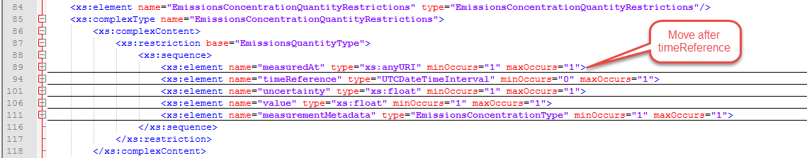

Figure - EmissionsConcentrationQuantityRestrictions Manual Edits

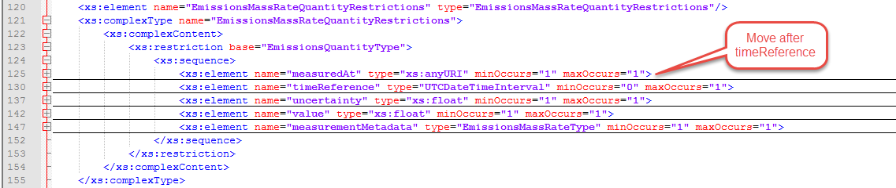

Figure - - EmissionsMassRateQuantityRestrictions Manual Edits

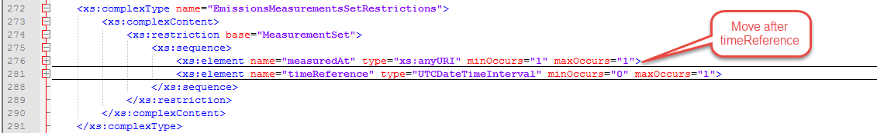

Figure - - EmissionsMeasurementsSetRestrictions Manual Edits

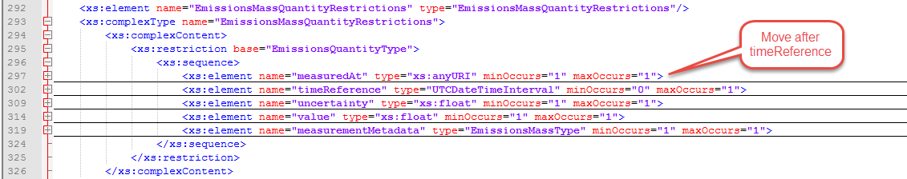

Figure - EmissionsMassQuantityRestrictions Manual Edits

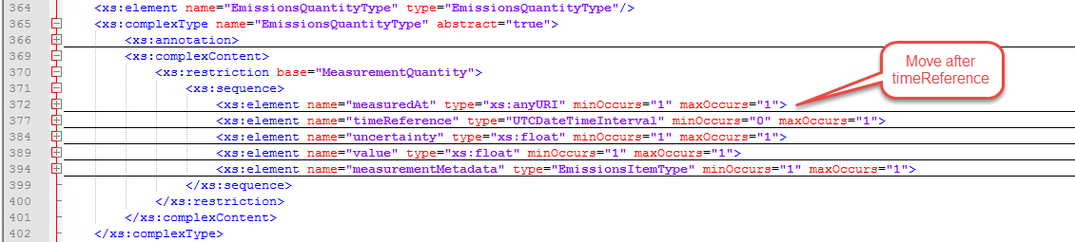

Figure - EmissionsQuantityType Manual Edits

* + 1. energy_meas.xsd

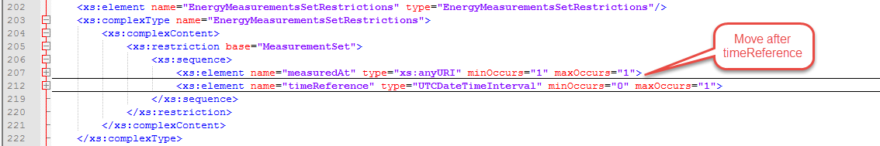

Figure - EnergyMeasurementsSetRestrictions Manual Edits

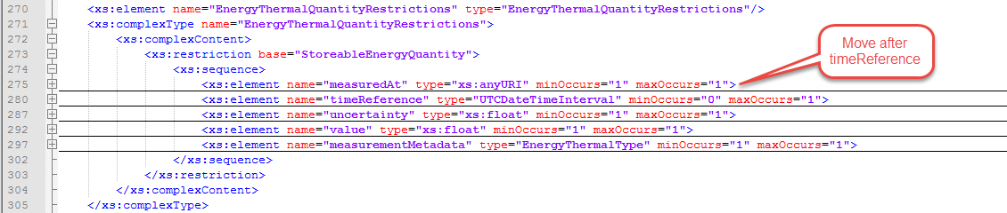

Figure - EnergyThermalQuantityRestrictions Manual Edits

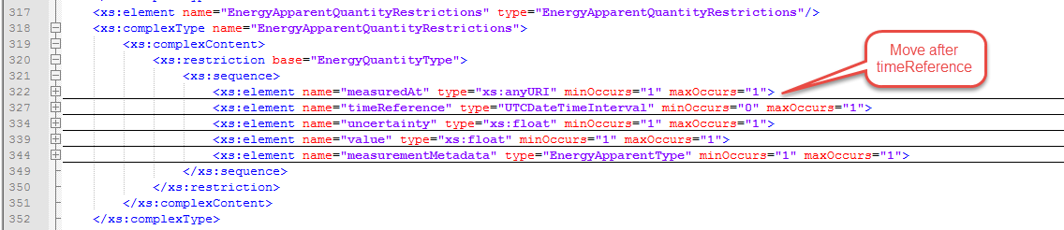

Figure - EnergyApparentQuantityRestrictions Manual Edits

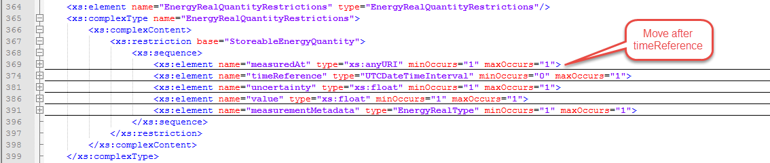

Figure - EnergyRealQuantityRestrictions Manual Edits

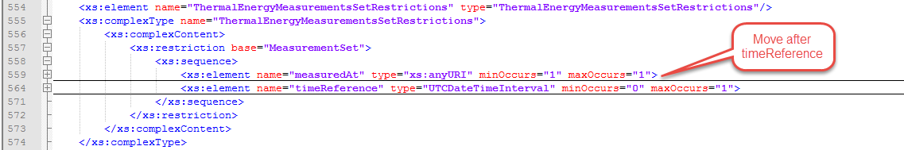

Figure - ThermalEnergyMeasurementsSetRestrictions Manual Edits

* + 1. fsgimweather.xsd

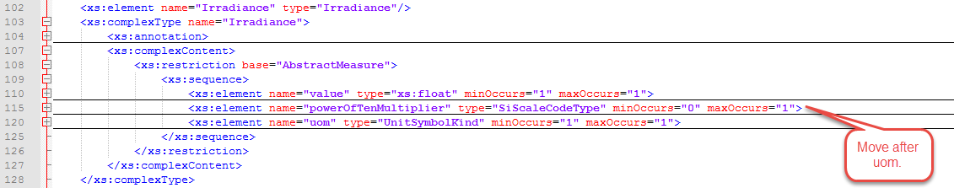

Figure - Irradiance Manual Edits

* + 1. measurements.xsd

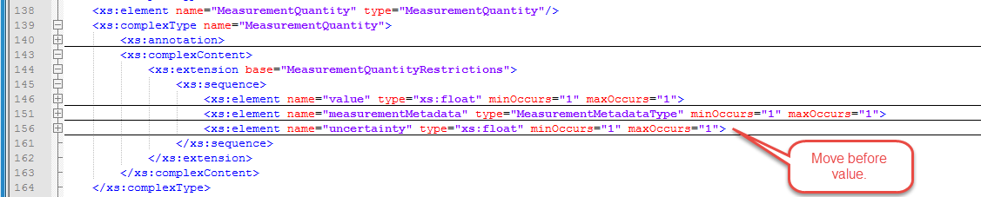

Figure - MeasurementQuantity Manual Edits

* + 1. measures.xsd

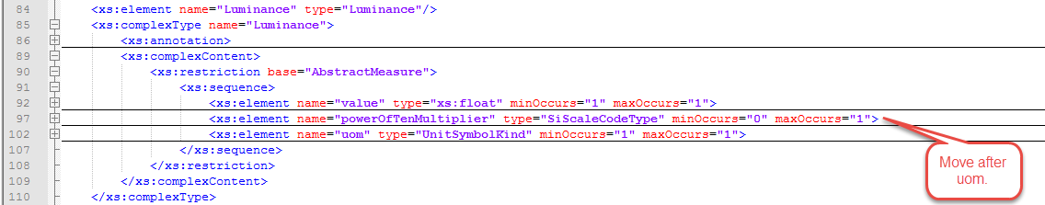

Figure - Luminance Manual Edits

* + 1. power_meas.xsd

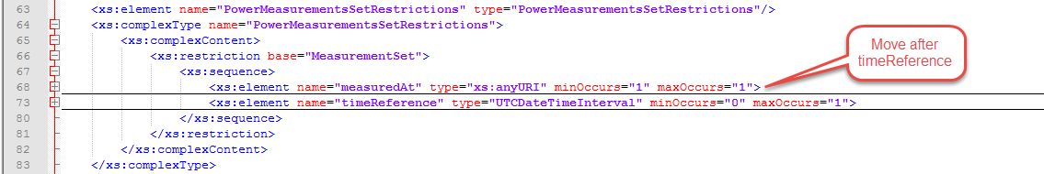

Figure - PowerMeasurementsSetRestrictions Manual Edits

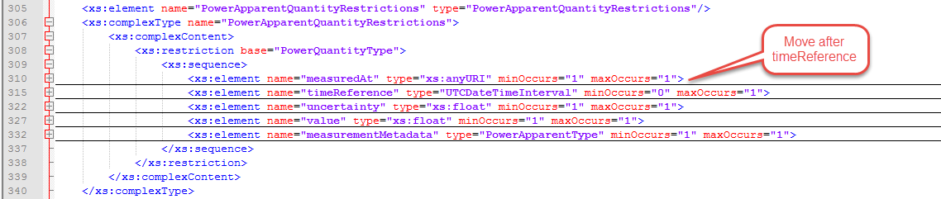

Figure - PowerApparentQuantityRestrictions Manual Edits

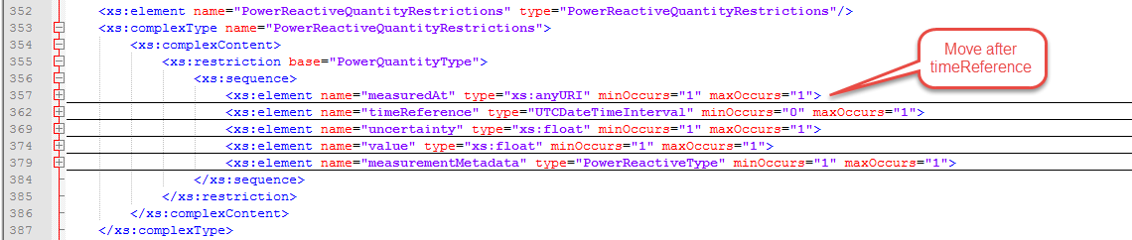

Figure - PowerReactiveQuantityRestrictions Manual Edits

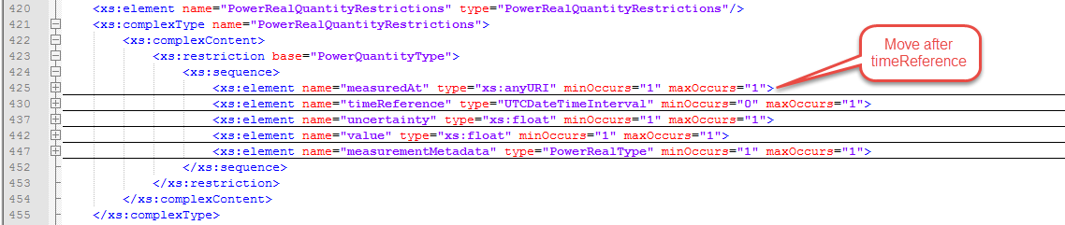

Figure - PowerRealQuantityRestrictions Manual Edits

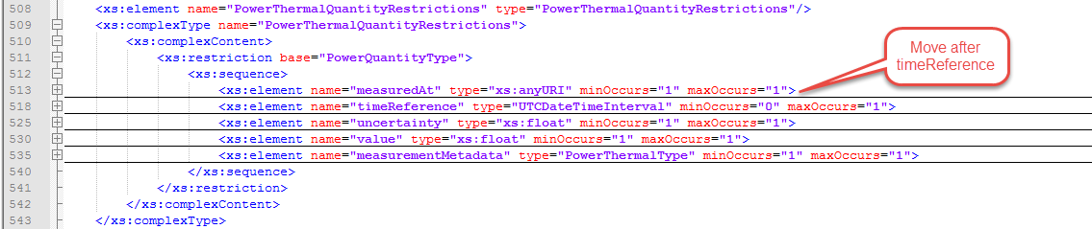

Figure - PowerThermalQuantityRestrictions Manual Edits

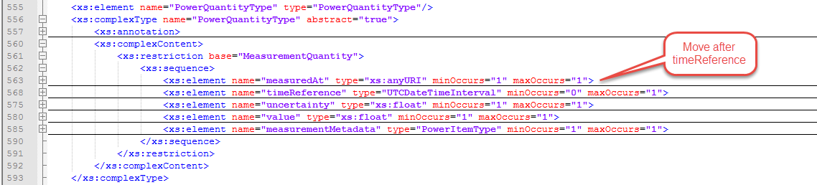

Figure - PowerQuantityType Manual Edits

1. From NIST RFQ- SB1341‐16‐RQ‐0528
2. The allowable values for GlobalID were later restricted as shown in Section 2.7.1, "Setting the "pattern" Value for GlobalID" in this document.
3. In addition to these changes, "SideType" was changed from having having a type that was a "typed-in" value of "string," (i.e., the word "string" had been entered by typing in the letters "s," "t," "r," "i," "n," and "g") to a "browsed-to" value of "<<XSDsimpleType>> string". Typing in the name of a data type instead of selecting the datatype by browsing to it yields a result that looks the same in the Enterprise Architect GUI, but that does not work correctly.
4. In addition to setting the anonymousRole to "false", PowerQualityWarrantType.measurementProtocol also had a Tagged Value of "anonymousType" that was set to "false" that preventing its schema from validating. This extra Tagged Value was deleted to make this attribute consistent with the rest of the model and to allow the schema to validate.
5. Eventually these two classes were merged and the need for a separate namespace was eliminated.
6. Observation.parameter:anyType is required by vaguely defined. It appears to be an extension mechanism. It does not appear to have been utilized anywhere in the FSGIM, so it was removed.
7. VerticallyBoundedPhenomenon is an abstract class. One of its child classes is CloudCondition. For CloudCondition, one or more of these attributes may be missing in a surface weather report. For example, the value of "base" would be reported as the cloud ceiling, but the "top" would not be reported.
8. Some diagrams, e.g. "AbstractObject and AbstractGML" show a parent class in the before picture but not the after picture. It is still there but does not show up because EA does not add those to the diagrams until the diagram is saved, closed, then reopened.